Exercise 1: Employee Management System - Overview and Setup
Business Scenario:
You are developing an employee management system that will manage employee data, departments, and their relationships.
Instructions:
- Creating a Spring Boot Project:
  - Initialize a new Spring Boot project named EmployeeManagementSystem.
  - Add dependencies: Spring Data JPA, H2 Database, Spring Web, Lombok.

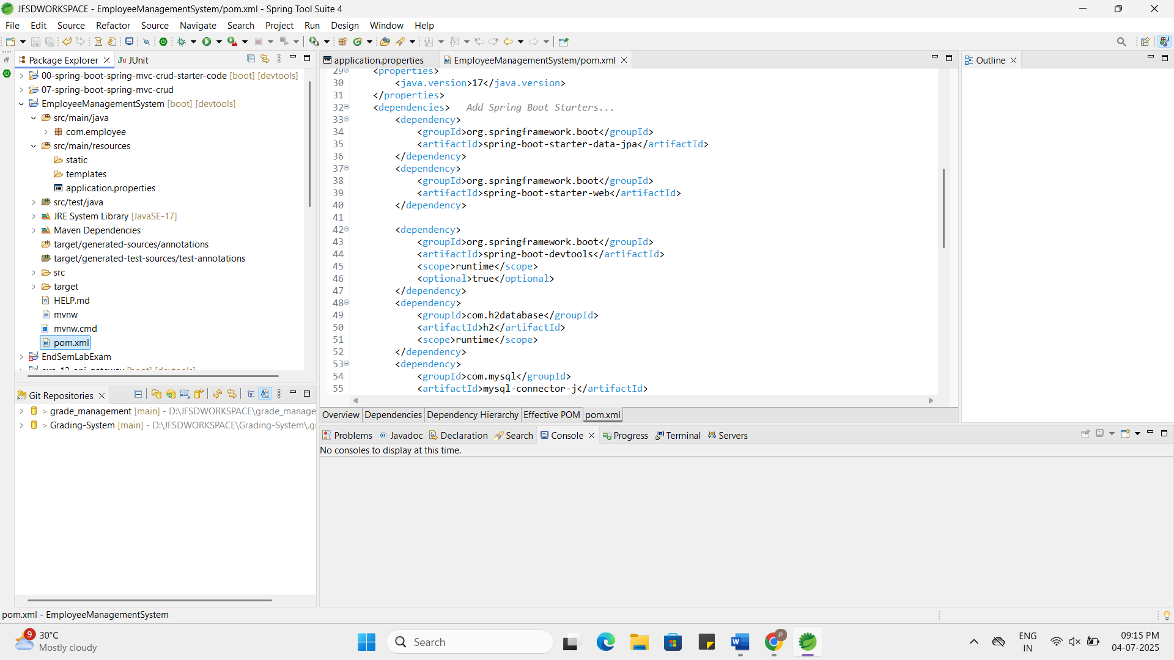

- Configuring Application Properties:
  - Configure application.properties for H2 database connection.
spring.datasource.url=jdbc:h2:mem:testdb
spring.datasource.driverClassName=org.h2.Driver
spring.datasource.username=sa
spring.datasource.password=password
spring.jpa.database-platform=org.hibernate.dialect.H2Dialect

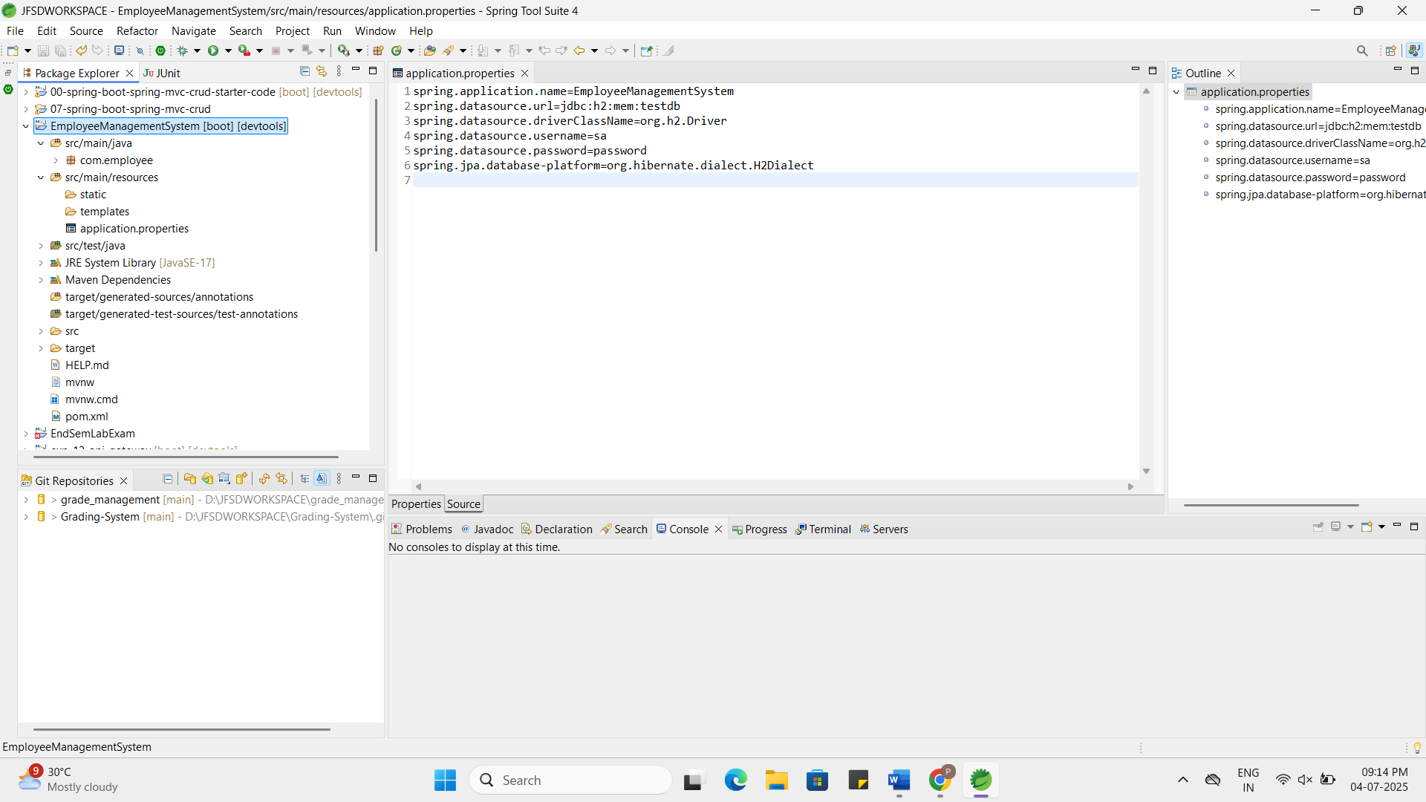
Exercise 2: Employee Management System - Creating Entities
Business Scenario:
Define JPA entities for Employee and Department with appropriate relationships.
Instructions:
- Creating JPA Entities:
  - Define Employee entity with fields: id, name, email, department.
  - Define Department entity with fields: id, name.
- Mapping Entities to Database Tables:
  - Use annotations like @Entity, @Table, @Id, @GeneratedValue, etc.
  - Define one-to-many relationship between Department and Employee.
Employee.java:
package com.employee.model;
import jakarta.persistence.*;
@Entity
@Table(name = "employees")
public class Employee {
@Id
@GeneratedValue(strategy = GenerationType.IDENTITY)
private Long id;
private String name;
private String email;
@ManyToOne
@JoinColumn(name = "department_id")
private Department department;
public Long getId() {
return id;
}
public String getName() {
return name;
}
public void setName(String name) {
this.name = name;
}
public String getEmail() {
return email;
}
public void setEmail(String email) {
this.email = email;
}
public Department getDepartment() {
return department;
}
public void setDepartment(Department department) {
this.department = department;
}
}
Department.java:
package com.employee.model;
import jakarta.persistence.*;
import java.util.List;
@Entity
@Table(name = "departments")
public class Department {
@Id
@GeneratedValue(strategy = GenerationType.IDENTITY)
private Long id;
private String name;
@OneToMany(mappedBy = "department", cascade = CascadeType.ALL)
private List<Employee> employees;
public Long getId() {
return id;
}
public String getName() {
return name;
}
public void setName(String name) {
this.name = name;
}
public List<Employee> getEmployees() {
return employees;
}
public void setEmployees(List<Employee> employees) {
this.employees = employees;
}
}
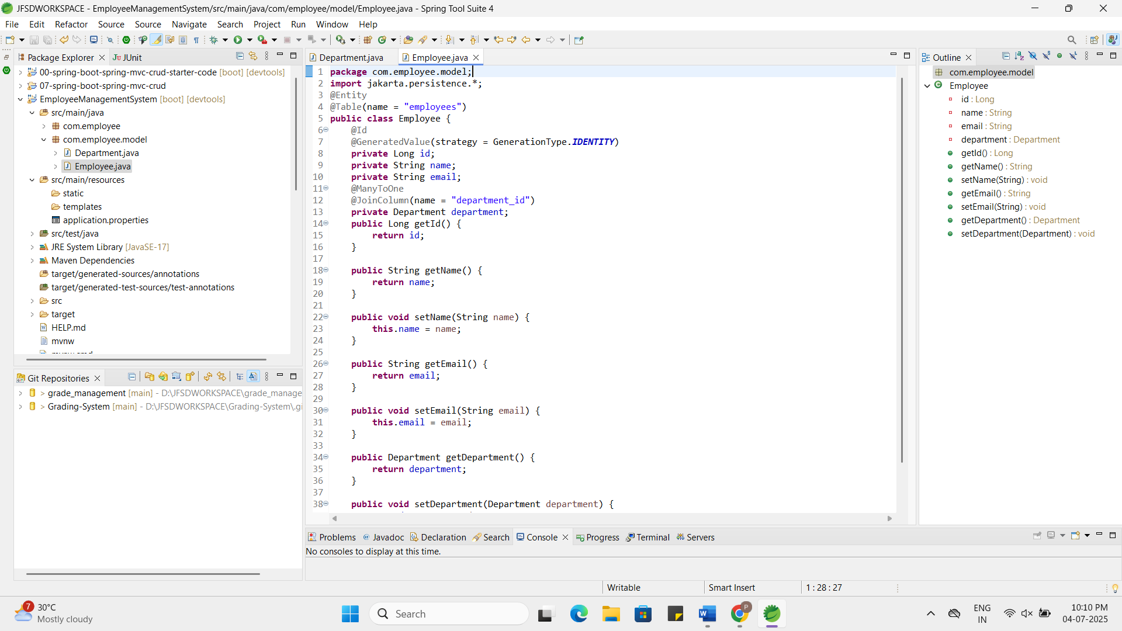

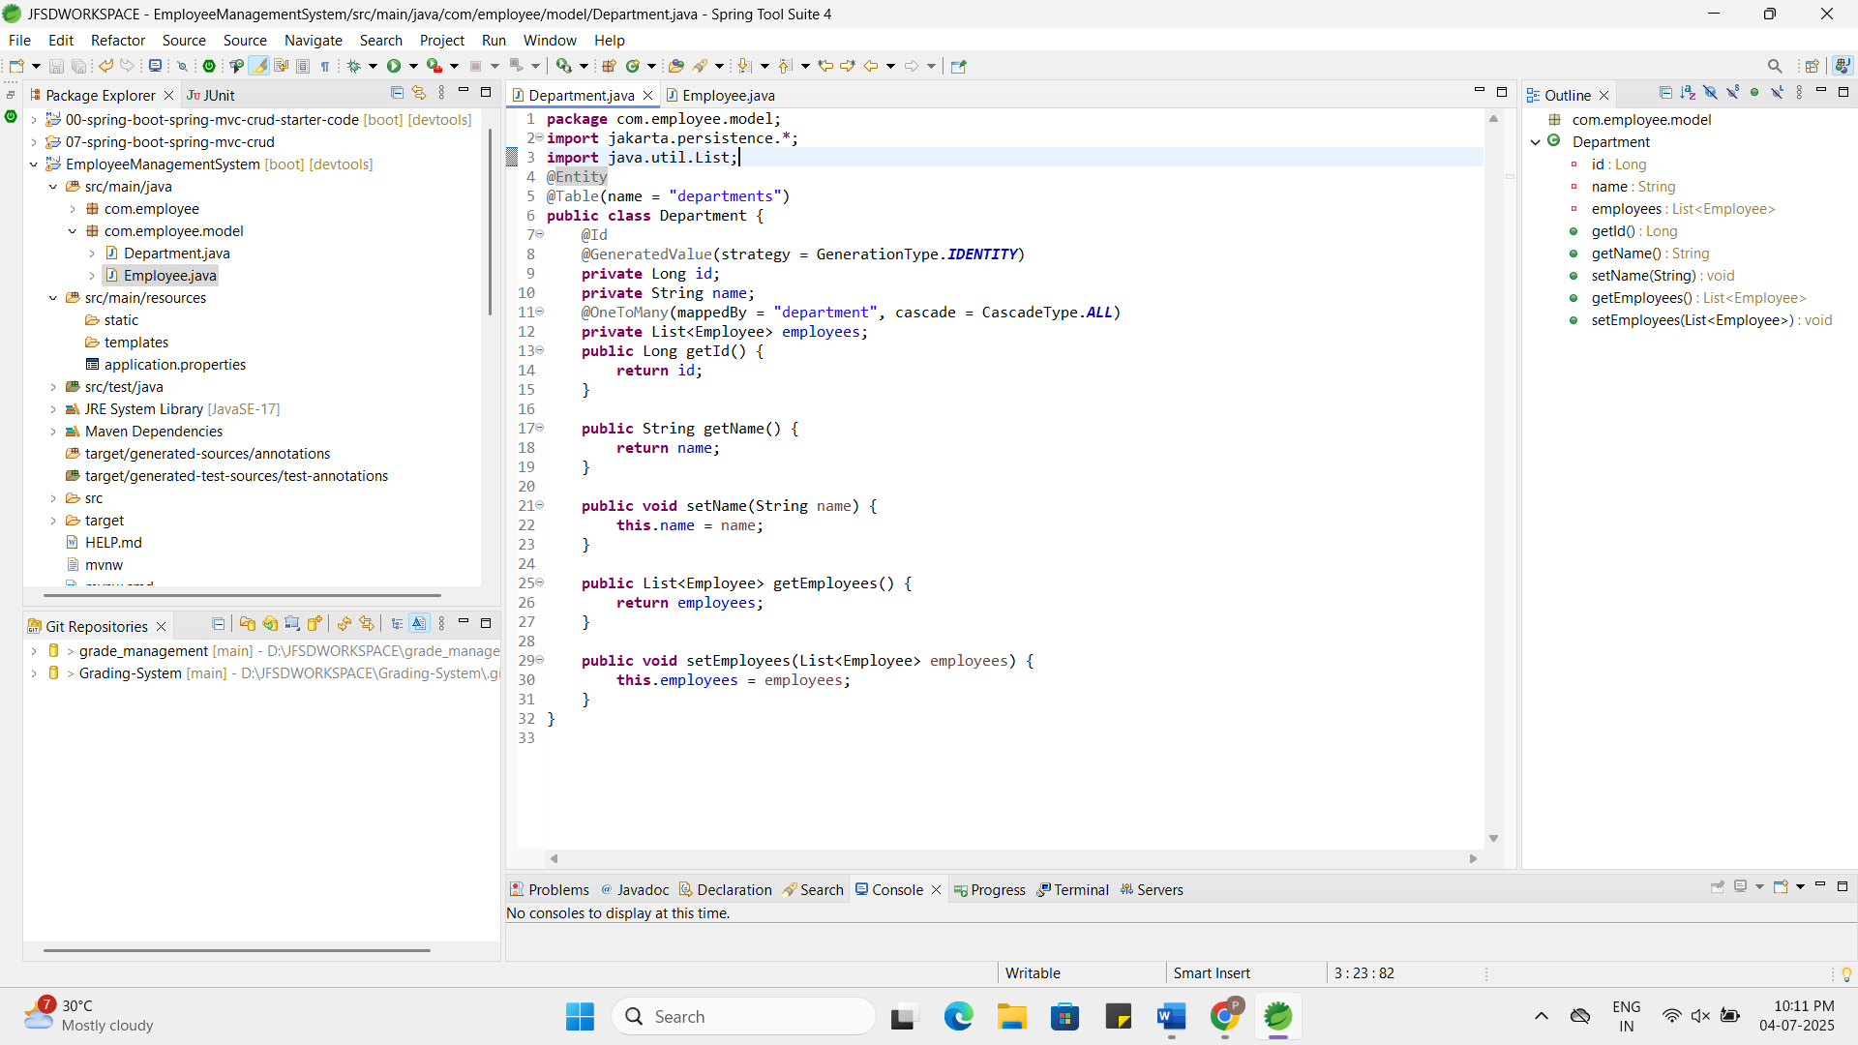

Exercise 3: Employee Management System - Creating Repositories
Business Scenario:
Create repositories for Employee and Department entities to perform CRUD operations.
Instructions:
- Overview of Spring Data Repositories:
  - Learn the benefits of using Spring Data repositories.
Answer:
Spring Data repositories help you do database operations (like save, update, delete, find) without writing SQL or complex code.
They provide ready-made methods like save(), findAll(), findById() etc. just by extending JpaRepository.
You can also create your own custom queries easily just by using method names.
This saves time and makes your code clean and easy to understand.
- Creating Repositories:
  - Create EmployeeRepository and DepartmentRepository interfaces extending JpaRepository.
  - Define derived query methods in these repositories.
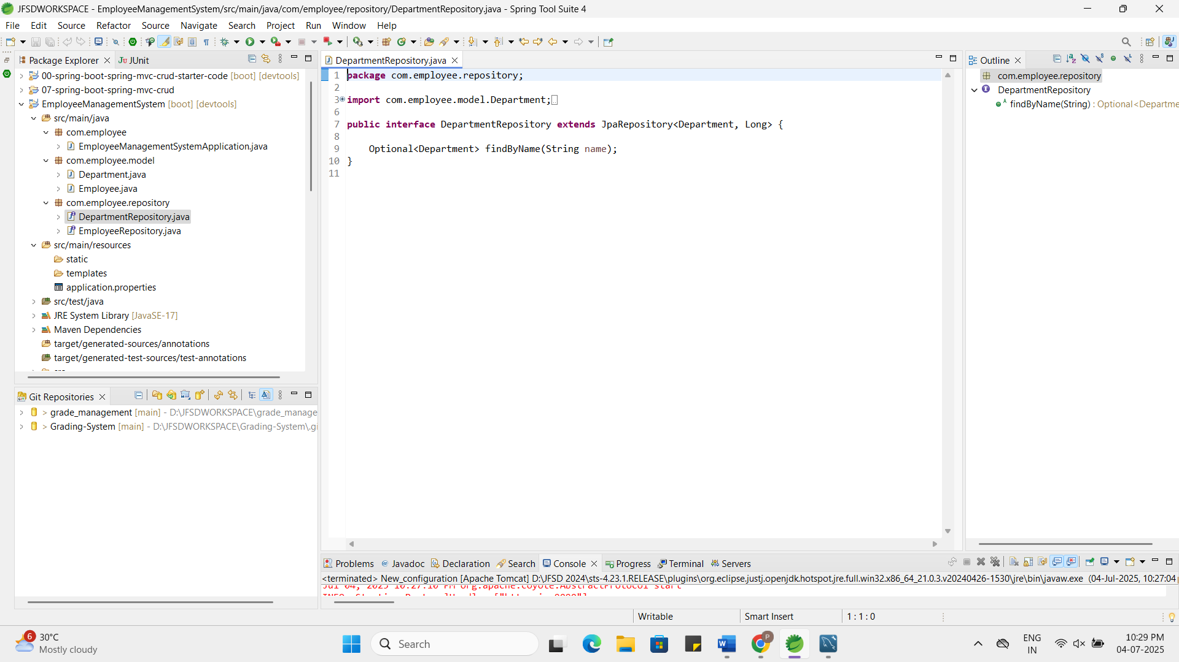

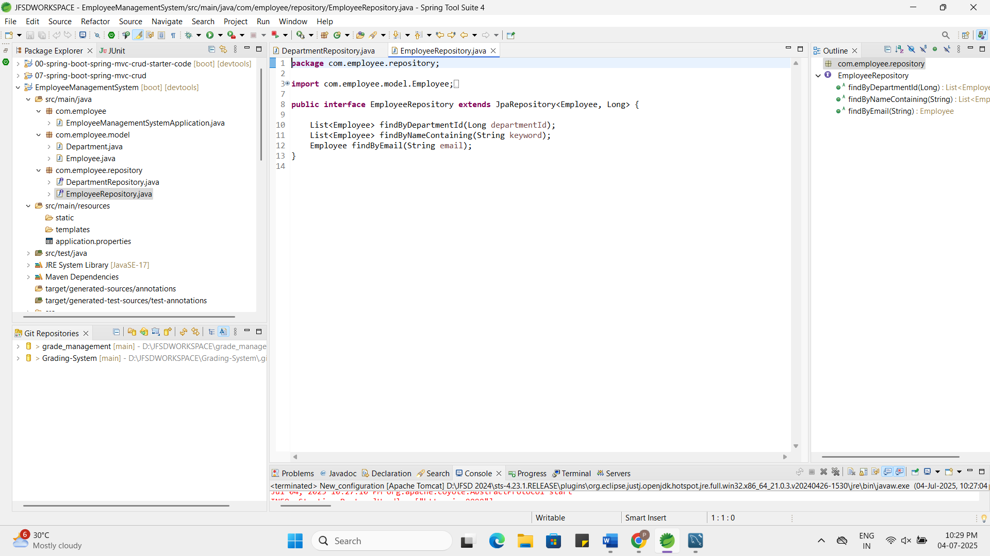

Exercise 4: Employee Management System - Implementing CRUD Operations
Business Scenario:
Implement CRUD operations for managing employees and departments.
Instructions:
- Basic CRUD Operations:
  - Use JpaRepository methods to create, read, update, and delete employees and departments.
  - Implement RESTful endpoints for these operations using EmployeeController and DepartmentController.
EmployeeController.java:
package com.employee.controller;
import com.employee.model.Employee;
import com.employee.repository.EmployeeRepository;
import org.springframework.beans.factory.annotation.Autowired;
import org.springframework.web.bind.annotation.*;
import java.util.List;
@RestController
@RequestMapping("/employees")
public class EmployeeController {
@Autowired
private EmployeeRepository employeeRepository;
@PostMapping
public Employee createEmployee(@RequestBody Employee employee) {
return employeeRepository.save(employee);
}
@GetMapping
public List<Employee> getAllEmployees() {
return employeeRepository.findAll();
}
@GetMapping("/{id}")
public Employee getEmployeeById(@PathVariable Long id) {
return employeeRepository.findById(id).orElse(null);
}
@PutMapping("/{id}")
public Employee updateEmployee(@PathVariable Long id, @RequestBody Employee updated) {
return employeeRepository.findById(id).map(emp -> {
emp.setName(updated.getName());
emp.setEmail(updated.getEmail());
emp.setDepartment(updated.getDepartment());
return employeeRepository.save(emp);
}).orElse(null);
}
@DeleteMapping("/{id}")
public void deleteEmployee(@PathVariable Long id) {
employeeRepository.deleteById(id);
}
}
DepartmentController.java:
package com.employee.controller;
import com.employee.model.Department;
import com.employee.repository.DepartmentRepository;
import org.springframework.beans.factory.annotation.Autowired;
import org.springframework.web.bind.annotation.*;
import java.util.List;
@RestController
@RequestMapping("/departments")
public class DepartmentController {
@Autowired
private DepartmentRepository departmentRepository;
@PostMapping
public Department createDepartment(@RequestBody Department department) {
return departmentRepository.save(department);
}
@GetMapping
public List<Department> getAllDepartments() {
return departmentRepository.findAll();
}
@GetMapping("/{id}")
public Department getDepartmentById(@PathVariable Long id) {
return departmentRepository.findById(id).orElse(null);
}
@PutMapping("/{id}")
public Department updateDepartment(@PathVariable Long id, @RequestBody Department dept) {
return departmentRepository.findById(id).map(existing -> {
existing.setName(dept.getName());
return departmentRepository.save(existing);
}).orElse(null);
}
@DeleteMapping("/{id}")
public void deleteDepartment(@PathVariable Long id) {
departmentRepository.deleteById(id);
}
}

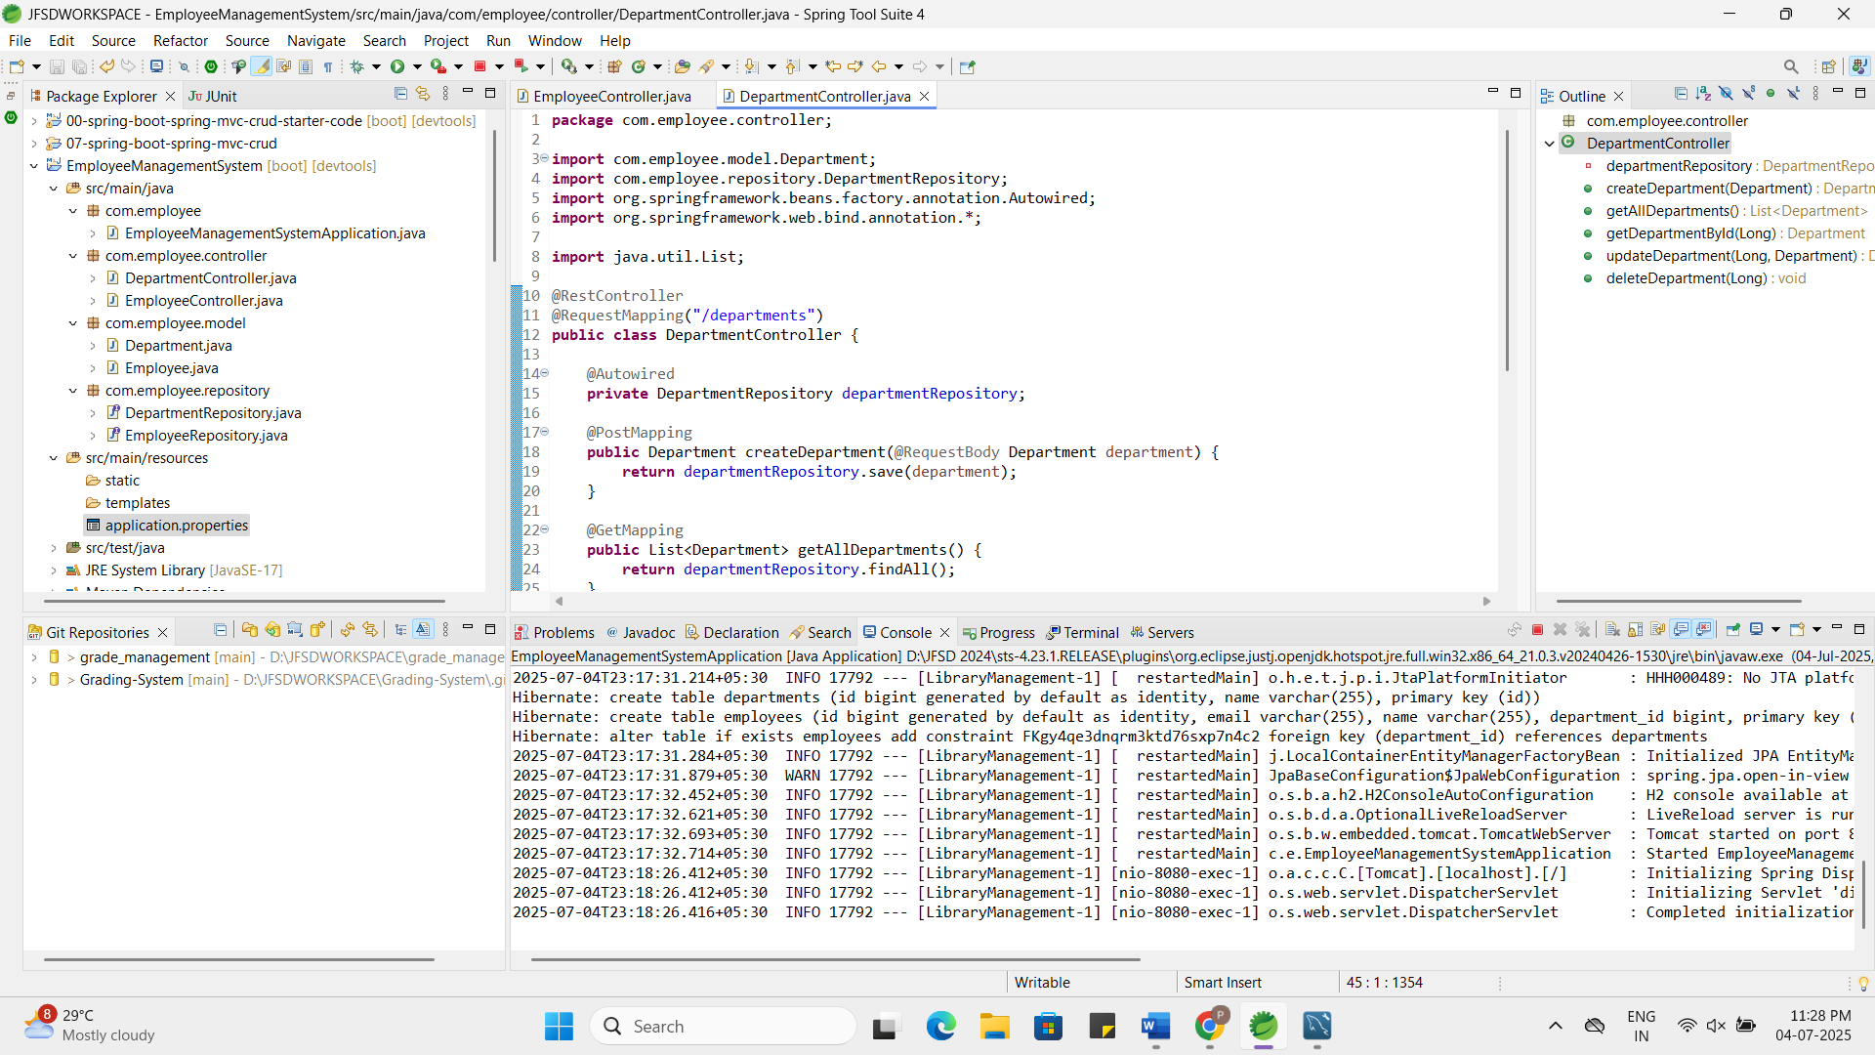

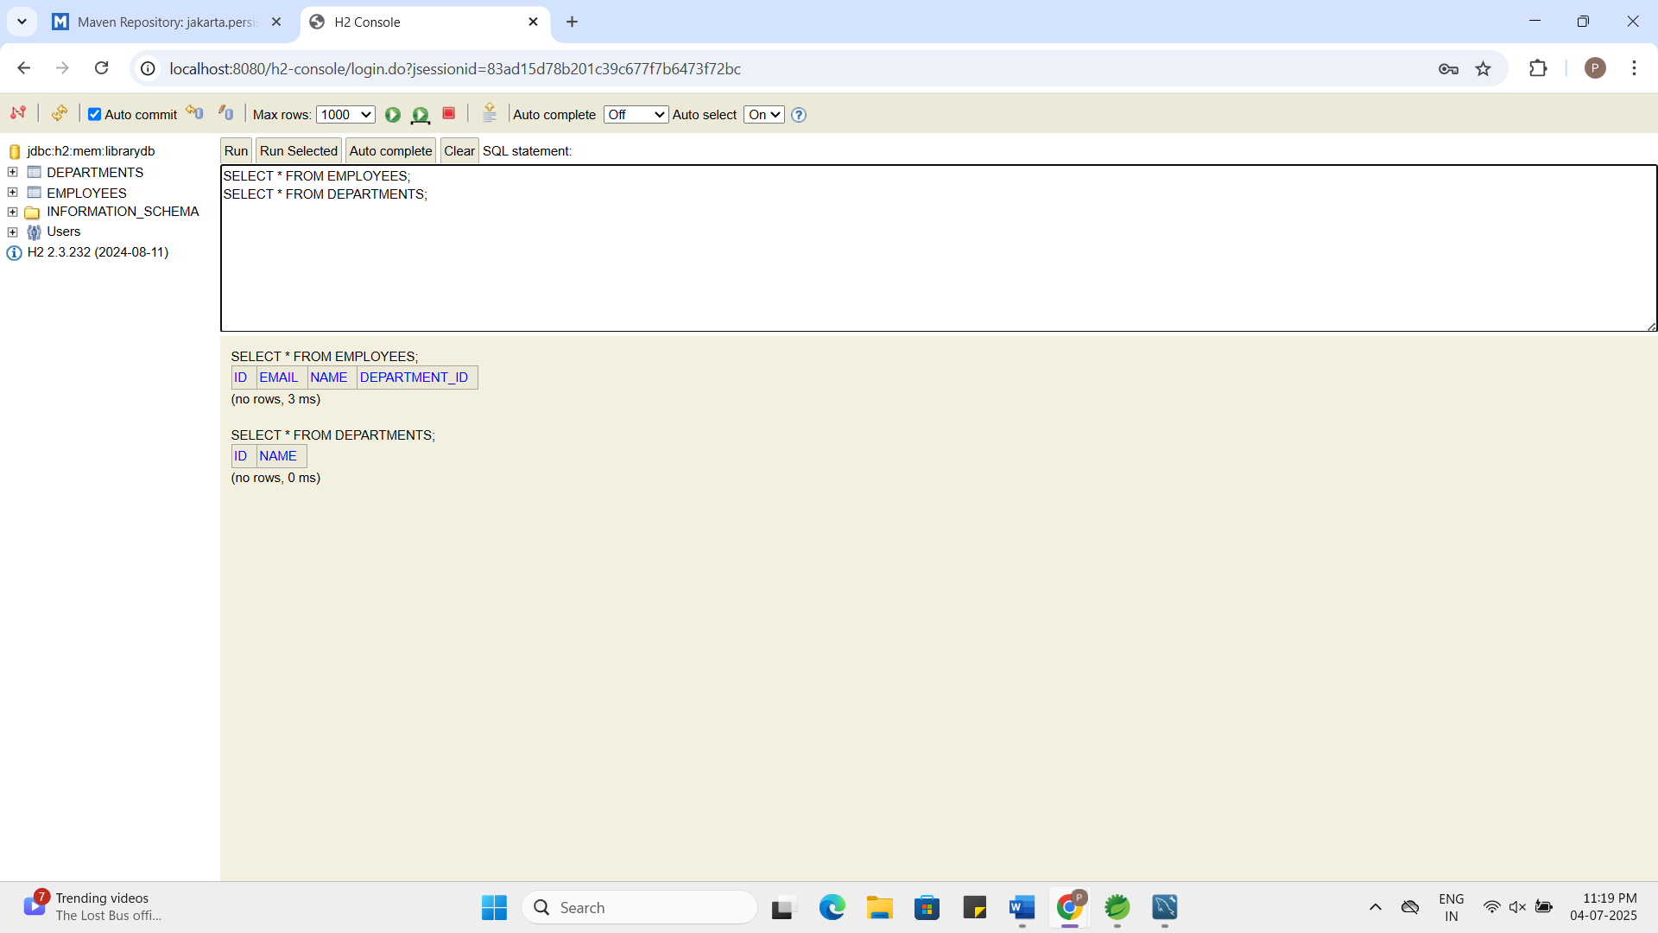

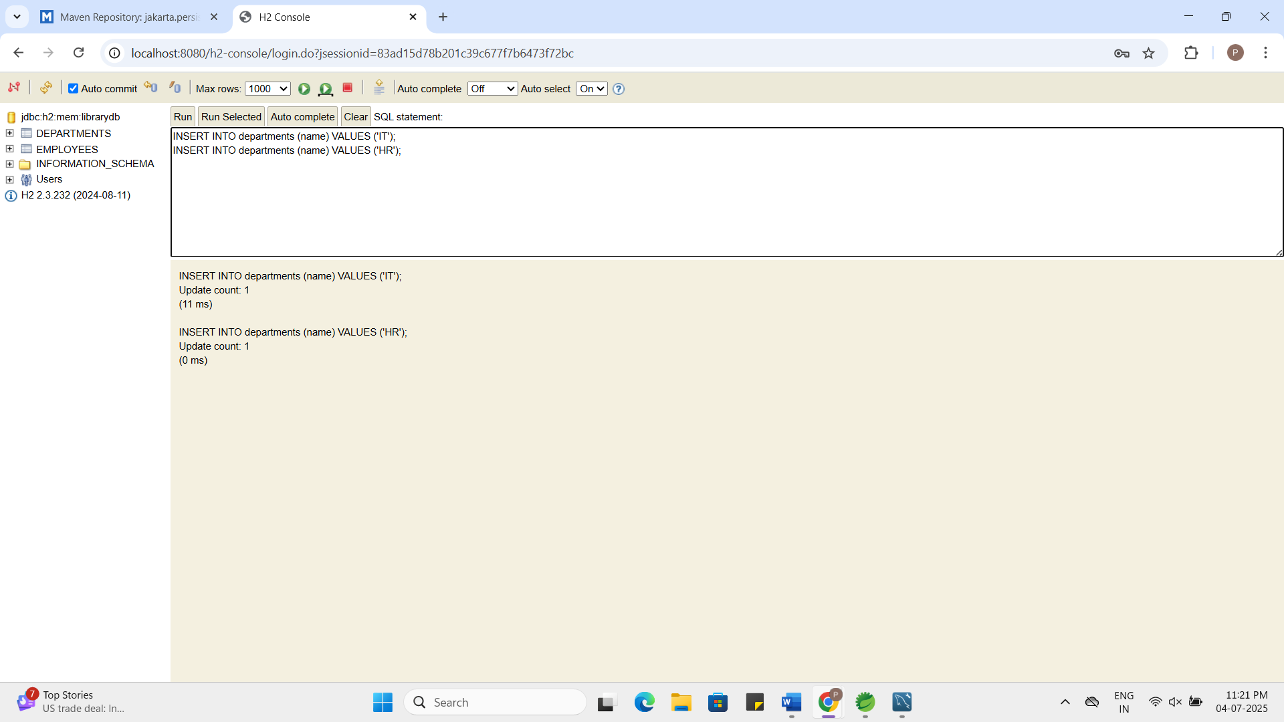

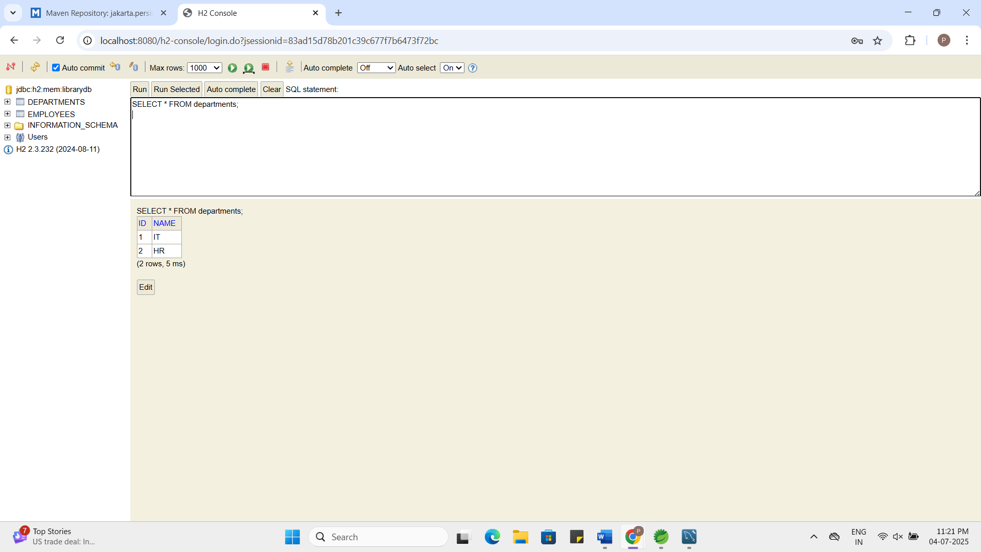

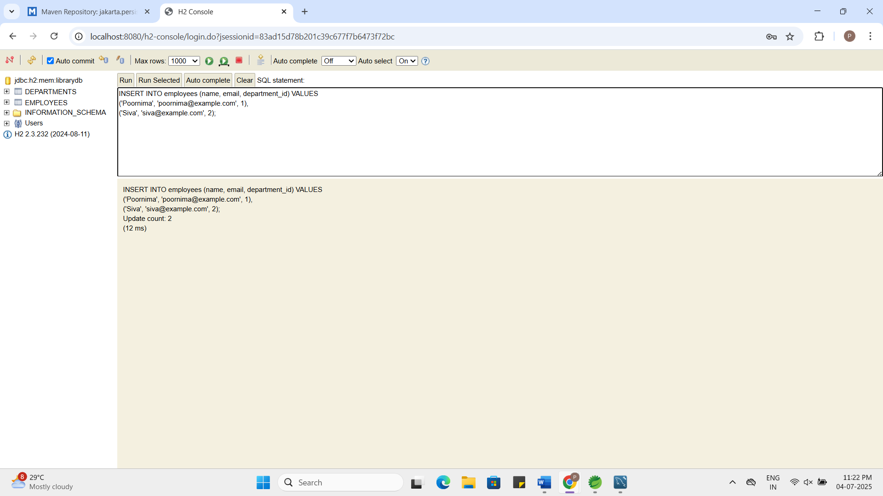

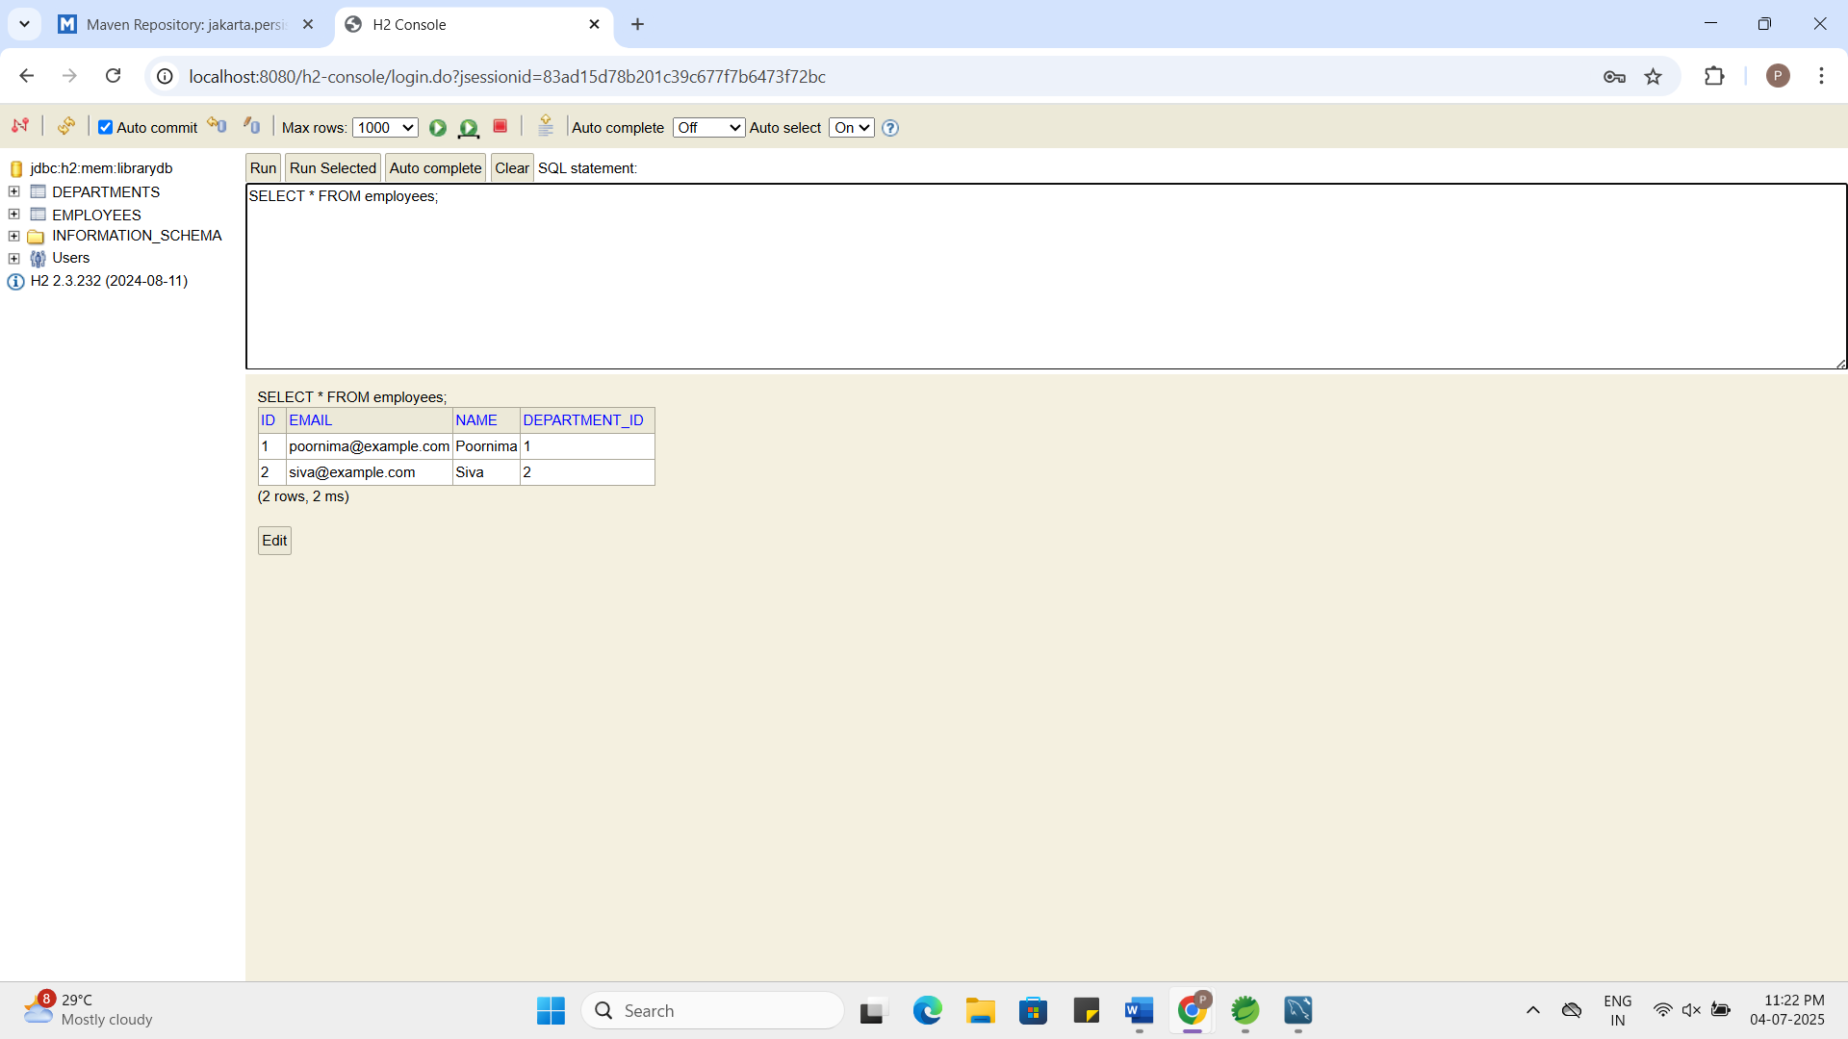
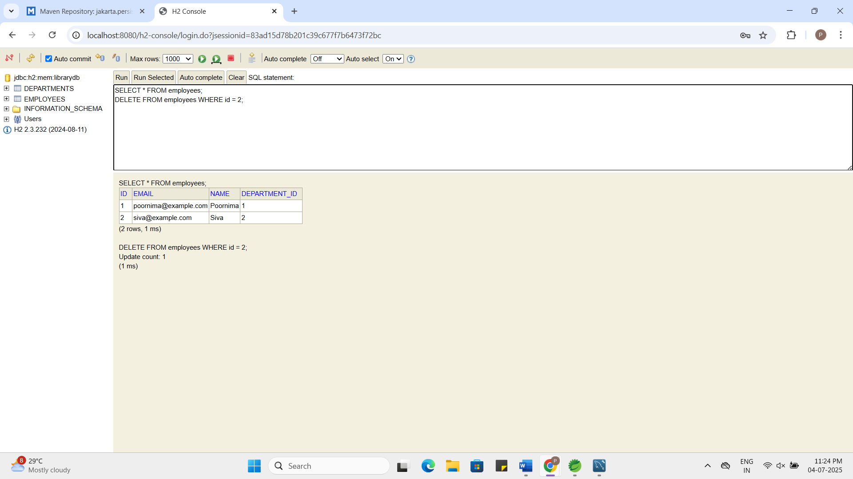
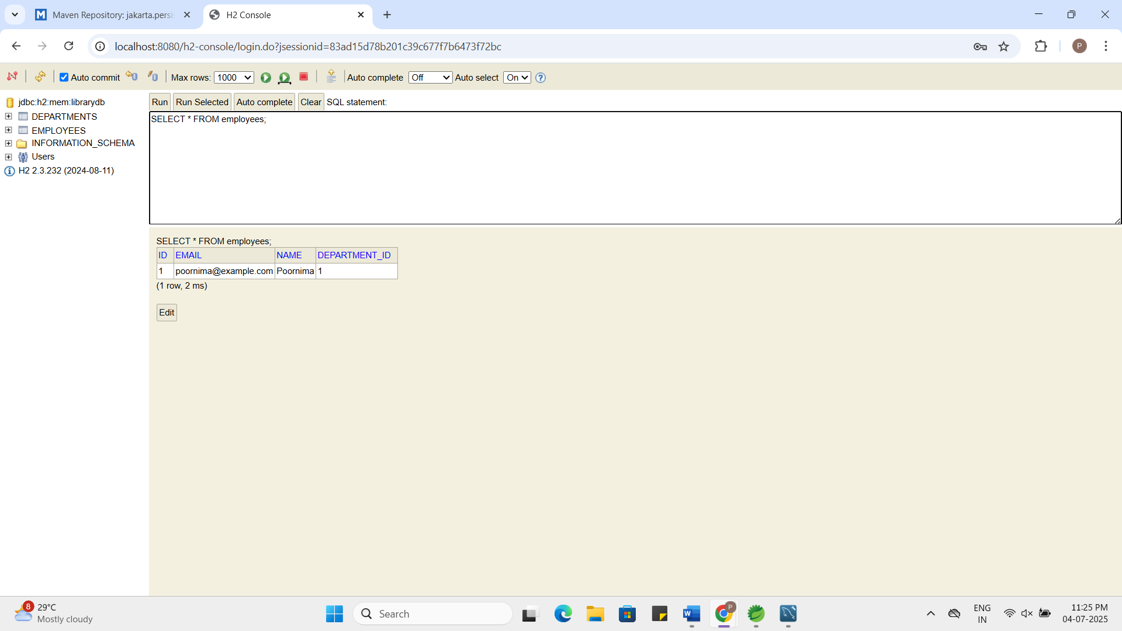

Exercise 5: Employee Management System - Defining Query Methods
Business Scenario:
Enhance your repository to support custom queries.
Instructions:
- Defining Query Methods:
  - Use keywords in method names to create custom query methods.
  - Implement custom query methods using the @Query annotation.
- Named Queries:
  - Define and execute named queries with @NamedQuery and @NamedQueries.
EmployeeController.java:
package com.employee.controller;
import com.employee.model.Employee;
import com.employee.repository.EmployeeRepository;
import org.springframework.beans.factory.annotation.Autowired;
import org.springframework.web.bind.annotation.*;

import java.util.List;
@RestController
@RequestMapping("/employees")
public class EmployeeController {
@Autowired
private EmployeeRepository employeeRepository;
@PostMapping
public Employee createEmployee(@RequestBody Employee employee) {
return employeeRepository.save(employee);
}
@GetMapping
public List<Employee> getAllEmployees() {
return employeeRepository.findAll();
}
@GetMapping("/{id}")
public Employee getEmployeeById(@PathVariable Long id) {
return employeeRepository.findById(id).orElse(null);
}
@PutMapping("/{id}")
public Employee updateEmployee(@PathVariable Long id, @RequestBody Employee updated) {
return employeeRepository.findById(id).map(emp -> {
emp.setName(updated.getName());
emp.setEmail(updated.getEmail());
emp.setDepartment(updated.getDepartment());
return employeeRepository.save(emp);
}).orElse(null);
}
@DeleteMapping("/{id}")
public void deleteEmployee(@PathVariable Long id) {
employeeRepository.deleteById(id);
}
@GetMapping("/search/by-name")
public List<Employee> getEmployeesByName(@RequestParam String name) {
return employeeRepository.findByName(name);
}
@GetMapping("/search/by-email-domain")
public List<Employee> getEmployeesByEmailDomain(@RequestParam String domain) {
return employeeRepository.findByEmailDomain(domain);
}
@GetMapping("/search/by-name-keyword")
public List<Employee> getEmployeesByNameKeyword(@RequestParam String keyword) {
return employeeRepository.searchByNameKeyword(keyword);
}
@GetMapping("/search/by-name-prefix")
public List<Employee> getEmployeesByNamePrefix(@RequestParam String prefix) {
return employeeRepository.findByNamePrefix(prefix + "%");
}
@GetMapping("/search/by-department-id")
public List<Employee> getEmployeesByDepartmentId(@RequestParam Long deptId) {
return employeeRepository.findByDeptId(deptId);
}
}
EmployeeRepository.java:
package com.employee.repository;
import com.employee.model.Employee;
import org.springframework.data.jpa.repository.JpaRepository;
import org.springframework.data.jpa.repository.Query;
import org.springframework.data.repository.query.Param;
import java.util.List;
public interface EmployeeRepository extends JpaRepository<Employee, Long> {
List<Employee> findByName(String name);
List<Employee> findByEmailContaining(String keyword);
List<Employee> findByDepartmentName(String departmentName);
@Query("SELECT e FROM Employee e WHERE e.email LIKE %:emailDomain")
List<Employee> findByEmailDomain(@Param("emailDomain") String domain);
@Query(value = "SELECT * FROM employees WHERE name LIKE %:keyword%", nativeQuery = true)
List<Employee> searchByNameKeyword(@Param("keyword") String keyword);
@Query(name = "Employee.findByNamePrefix")
List<Employee> findByNamePrefix(@Param("prefix") String prefix);
@Query(name = "Employee.findByDepartmentId")
List<Employee> findByDeptId(@Param("deptId") Long deptId);
}
Employee.java:
package com.employee.model;
import jakarta.persistence.*;
import java.io.Serializable;
@Entity
@Table(name = "employees")
@NamedQueries({
@NamedQuery(
name = "Employee.findByNamePrefix",
query = "SELECT e FROM Employee e WHERE e.name LIKE :prefix"
),
@NamedQuery(
name = "Employee.findByDepartmentId",
query = "SELECT e FROM Employee e WHERE e.department.id = :deptId"
)
})
public class Employee implements Serializable {
@Id
@GeneratedValue(strategy = GenerationType.IDENTITY)
private Long id;
private String name;
private String email;
@ManyToOne
@JoinColumn(name = "department_id")
private Department department;
public Long getId() {
return id;
}
public void setId(Long id) {
this.id = id;
}
public String getName() {
return name;
}

public void setName(String name) {
this.name = name;
}
public String getEmail() {
return email;
}
public void setEmail(String email) {
this.email = email;
}
public Department getDepartment() {
return department;
}
public void setDepartment(Department department) {
this.department = department;
}
}

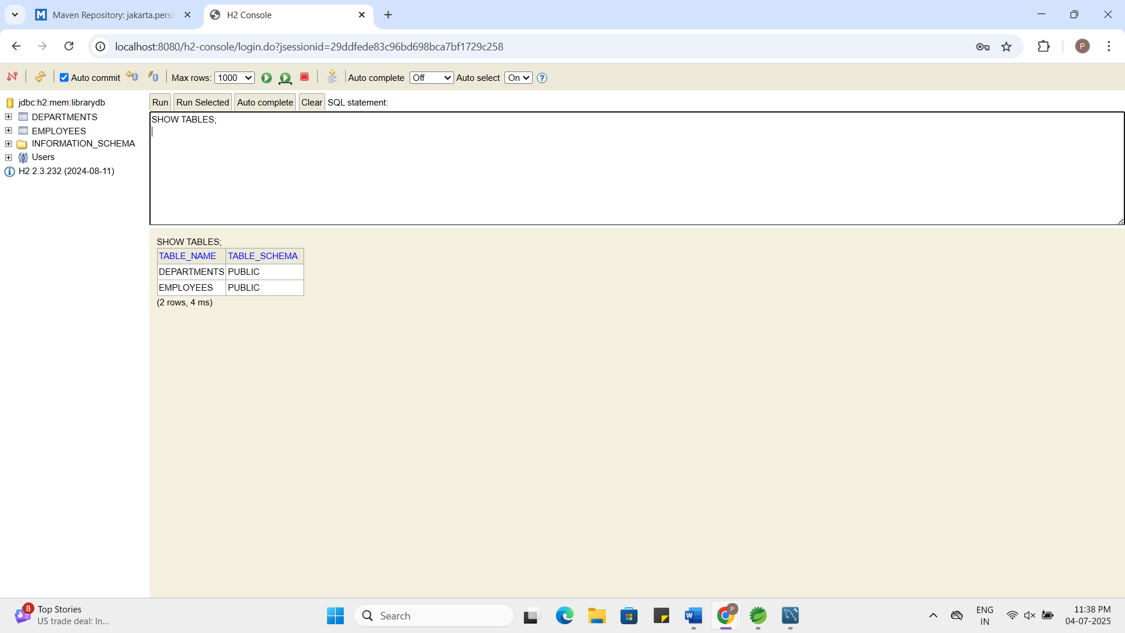
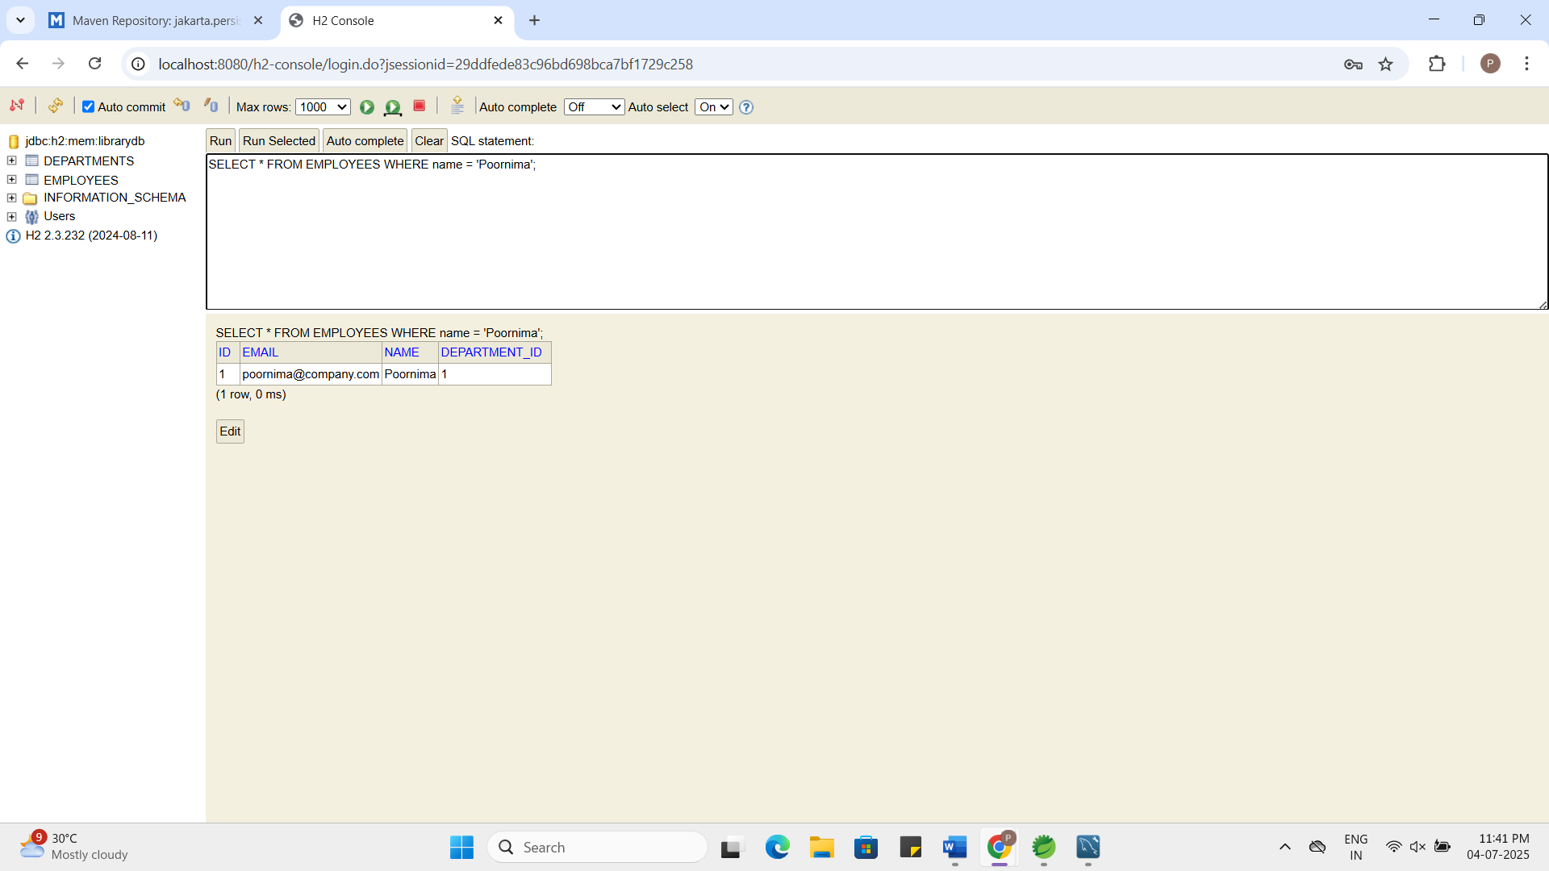

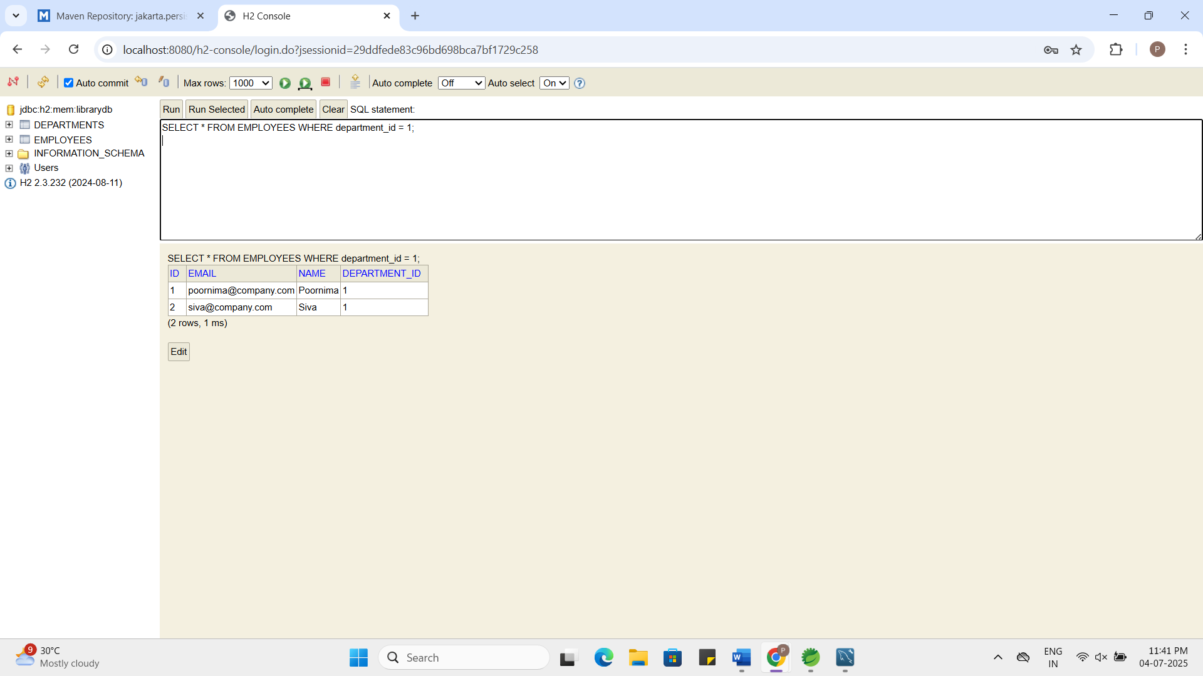

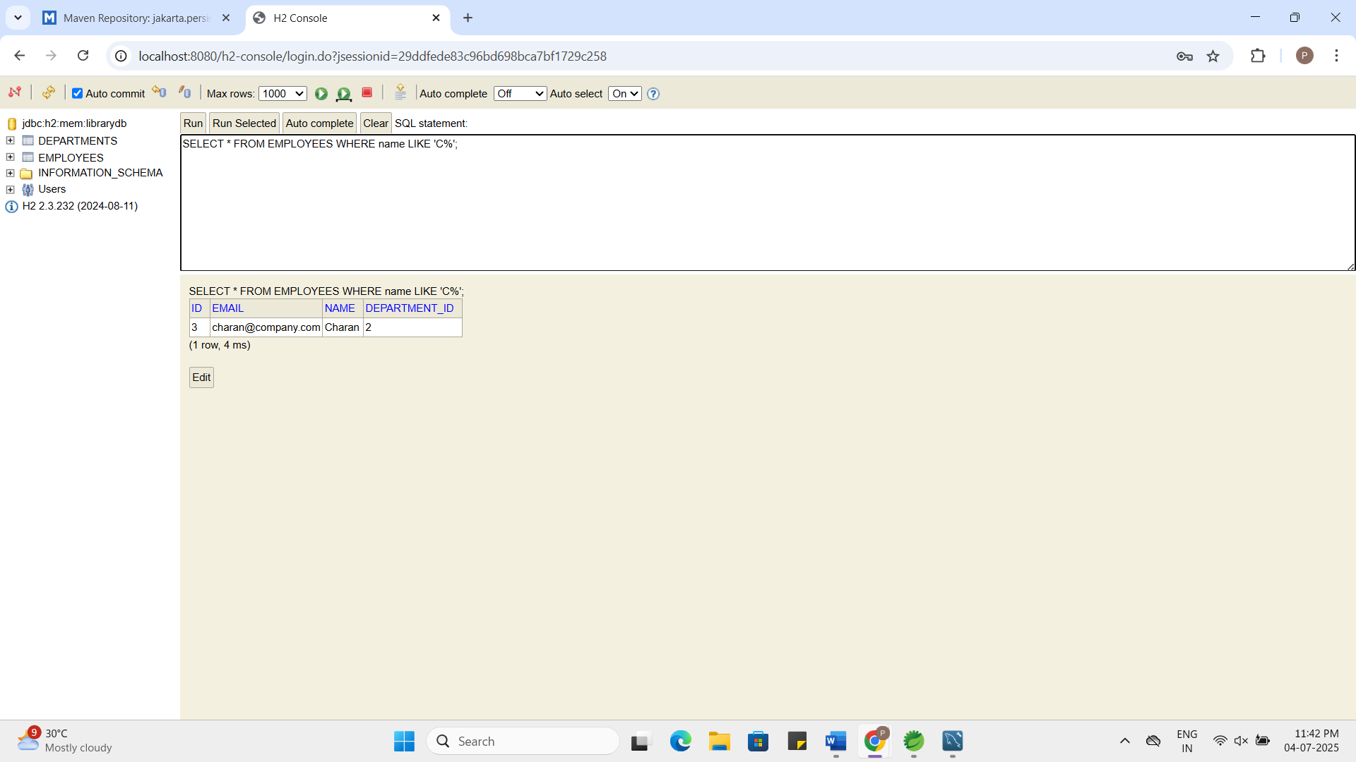

Exercise 6: Employee Management System - Implementing Pagination and Sorting
Business Scenario:
Add pagination and sorting capabilities to your employee search functionality.
Instructions:
- Pagination:
  - Implement pagination for the employee list using Page and Pageable.
- Sorting:
  - Add sorting functionality to your queries.
  - Combine pagination and sorting in your search endpoint.
EmployeeController.java:
package com.employee.controller;
import com.employee.model.Employee;
import com.employee.repository.EmployeeRepository;
import org.springframework.beans.factory.annotation.Autowired;
import org.springframework.data.domain.*;
import org.springframework.web.bind.annotation.*;
import java.util.List;

@RestController
@RequestMapping("/employees")
public class EmployeeController {
@Autowired
private EmployeeRepository employeeRepository;
@PostMapping
public Employee createEmployee(@RequestBody Employee employee) {
return employeeRepository.save(employee);
}
@GetMapping
public List<Employee> getAllEmployees() {
return employeeRepository.findAll();
}
@GetMapping("/{id}")
public Employee getEmployeeById(@PathVariable Long id) {
return employeeRepository.findById(id).orElse(null);
}
@PutMapping("/{id}")
public Employee updateEmployee(@PathVariable Long id, @RequestBody Employee updated) {
return employeeRepository.findById(id).map(emp -> {
emp.setName(updated.getName());
emp.setEmail(updated.getEmail());
emp.setDepartment(updated.getDepartment());
return employeeRepository.save(emp);
}).orElse(null);
}
@DeleteMapping("/{id}")
public void deleteEmployee(@PathVariable Long id) {
employeeRepository.deleteById(id);
}
@GetMapping("/search/by-name")
public List<Employee> getEmployeesByName(@RequestParam String name) {
return employeeRepository.findByName(name);
}
@GetMapping("/search/by-email-domain")
public List<Employee> getEmployeesByEmailDomain(@RequestParam String domain) {
return employeeRepository.findByEmailDomain(domain);
}
@GetMapping("/search/by-name-keyword")
public List<Employee> getEmployeesByNameKeyword(@RequestParam String keyword) {
return employeeRepository.searchByNameKeyword(keyword);
}
@GetMapping("/search/by-name-prefix")
public List<Employee> getEmployeesByNamePrefix(@RequestParam String prefix) {
return employeeRepository.findByNamePrefix(prefix);
}
@GetMapping("/search/by-department-id")
public List<Employee> getEmployeesByDepartmentId(@RequestParam Long deptId) {
return employeeRepository.findByDeptId(deptId);
}

@GetMapping("/paginated")
public Page<Employee> getPaginatedEmployees(
@RequestParam(defaultValue = "0") int page,
@RequestParam(defaultValue = "5") int size,
@RequestParam(defaultValue = "id") String sortBy,
@RequestParam(defaultValue = "asc") String sortDir) {
Sort sort = sortDir.equalsIgnoreCase("asc")
? Sort.by(sortBy).ascending()
: Sort.by(sortBy).descending();

Pageable pageable = PageRequest.of(page, size, sort);
return employeeRepository.findAll(pageable);
}
}

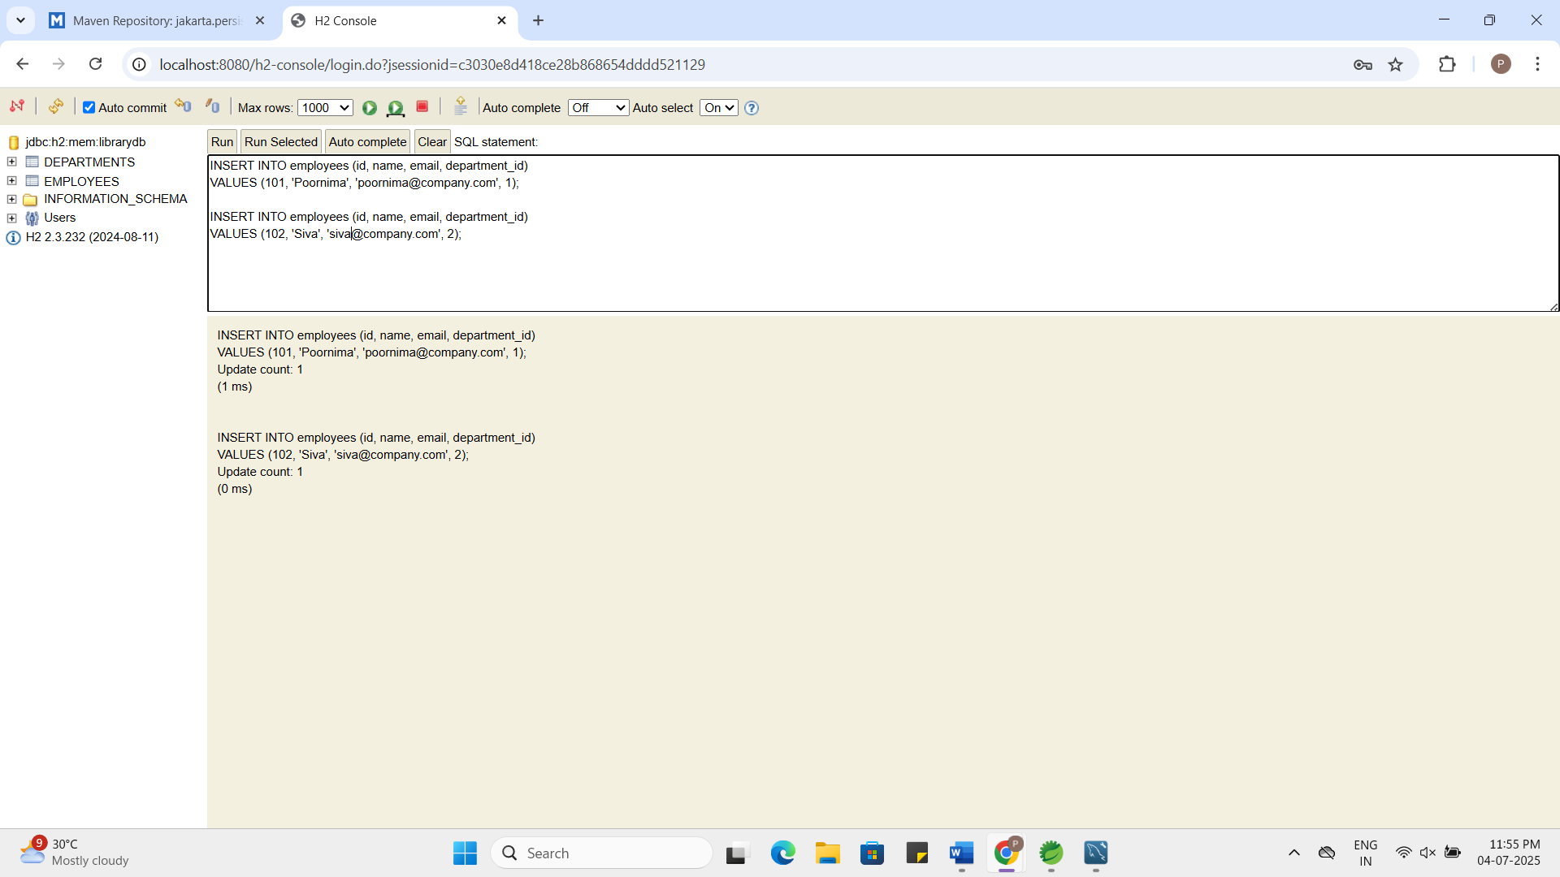

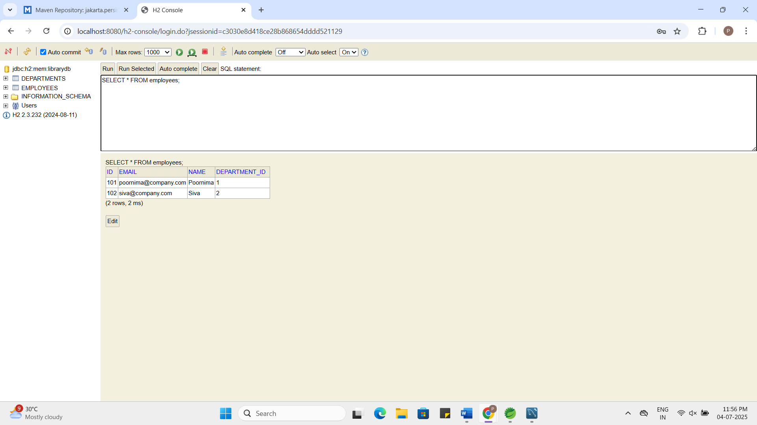

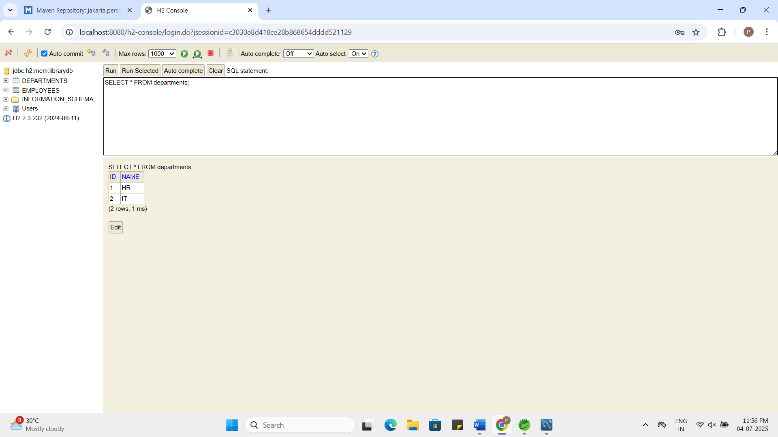

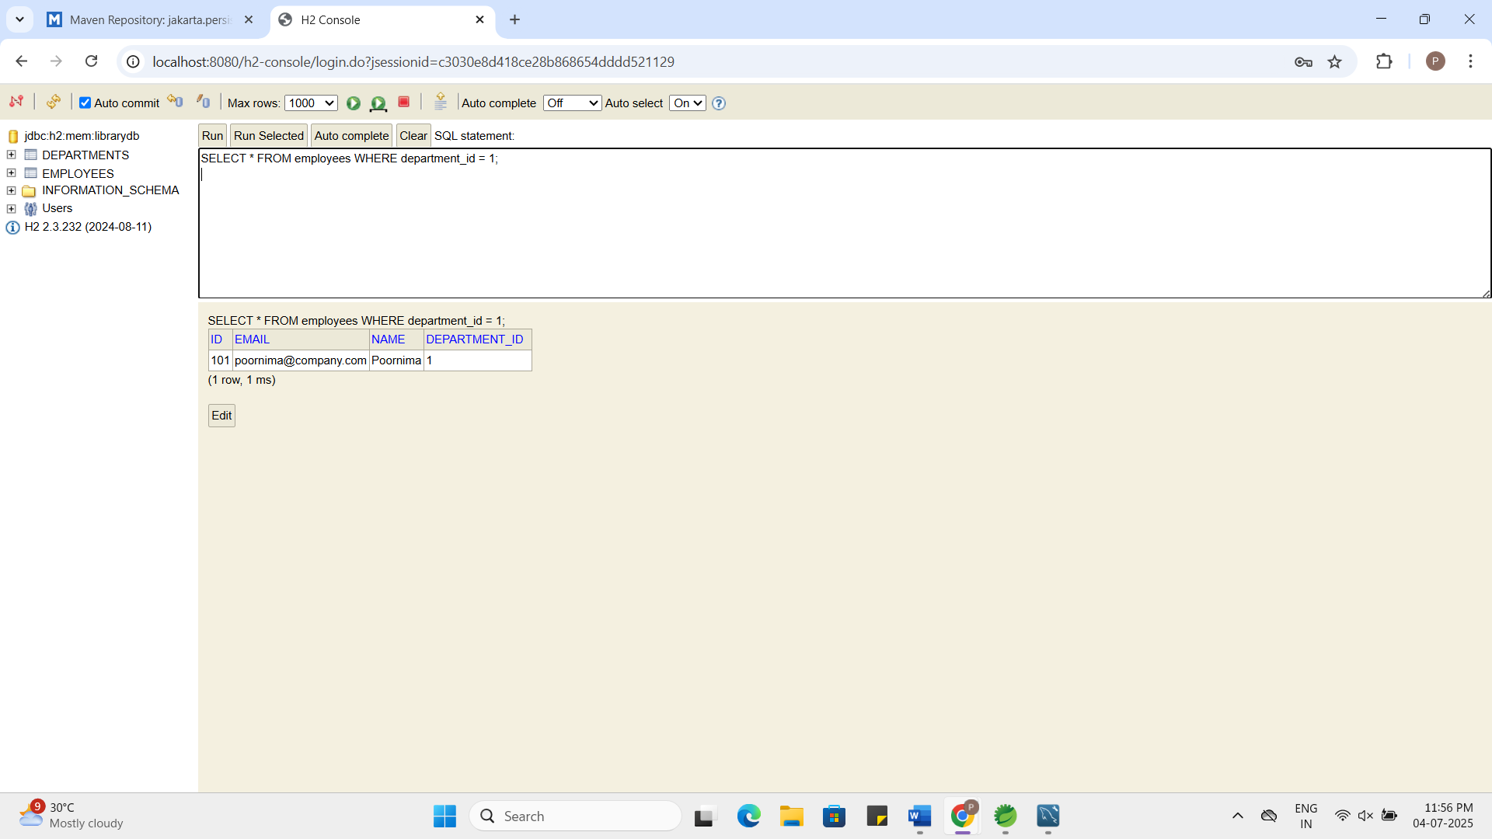

Exercise 7: Employee Management System - Enabling Entity Auditing
Business Scenario:
Implement auditing to track the creation and modification of employees and departments.
Instructions:
- Entity Auditing:
  - Enable auditing in your application by configuring auditing properties.
  - Use annotations like @CreatedBy, @LastModifiedBy, @CreatedDate, and @LastModifiedDate.

Employee.java:

package com.employee.model;
import jakarta.persistence.*;
import org.springframework.data.annotation.CreatedBy;
import org.springframework.data.annotation.CreatedDate;
import org.springframework.data.annotation.LastModifiedBy;
import org.springframework.data.annotation.LastModifiedDate;
import org.springframework.data.jpa.domain.support.AuditingEntityListener;
import java.time.LocalDateTime;
@Entity
@Table(name = "employees")
@EntityListeners(AuditingEntityListener.class)
public class Employee {
@Id
@GeneratedValue(strategy = GenerationType.IDENTITY)
private Long id;
private String name;
private String email;
@ManyToOne
@JoinColumn(name = "department_id")
private Department department;
@CreatedDate
@Column(updatable = false)
private LocalDateTime createdDate;
@LastModifiedDate
private LocalDateTime lastModifiedDate;
@CreatedBy
@Column(updatable = false)
private String createdBy;
@LastModifiedBy
private String lastModifiedBy;
public Long getId() {
return id;
}
public void setId(Long id) {
this.id = id;
}
public String getName() {
return name;
}
public void setName(String name) {
this.name = name;
}

public String getEmail() {
return email;
}

public void setEmail(String email) {
this.email = email;
}
public Department getDepartment() {
return department;
}
public void setDepartment(Department department) {
this.department = department;
}
public LocalDateTime getCreatedDate() {
return createdDate;
}
public void setCreatedDate(LocalDateTime createdDate) {
this.createdDate = createdDate;
}
public LocalDateTime getLastModifiedDate() {
return lastModifiedDate;
}
public void setLastModifiedDate(LocalDateTime lastModifiedDate) {
this.lastModifiedDate = lastModifiedDate;
}
public String getCreatedBy() {
return createdBy;
}

public void setCreatedBy(String createdBy) {
this.createdBy = createdBy;
}
public String getLastModifiedBy() {
return lastModifiedBy;
}
public void setLastModifiedBy(String lastModifiedBy) {
this.lastModifiedBy = lastModifiedBy;
}

}

EmployeeManagementSystemApplication.java:

package com.employee;
import org.springframework.boot.SpringApplication;
import org.springframework.boot.autoconfigure.SpringBootApplication;
import org.springframework.data.jpa.repository.config.EnableJpaAuditing;
@SpringBootApplication
@EnableJpaAuditing
public class EmployeeManagementSystemApplication {
public static void main(String[] args) {
SpringApplication.run(EmployeeManagementSystemApplication.class, args);
}
}

AuditConfig.java:

package com.employee.config;
import org.springframework.context.annotation.Configuration;
import org.springframework.context.annotation.Bean;
import org.springframework.data.domain.AuditorAware;
import java.util.Optional;
@Configuration
public class AuditConfig {
@Bean
public AuditorAware<String> auditorProvider() {
return () -> Optional.of("admin-user");
}
}

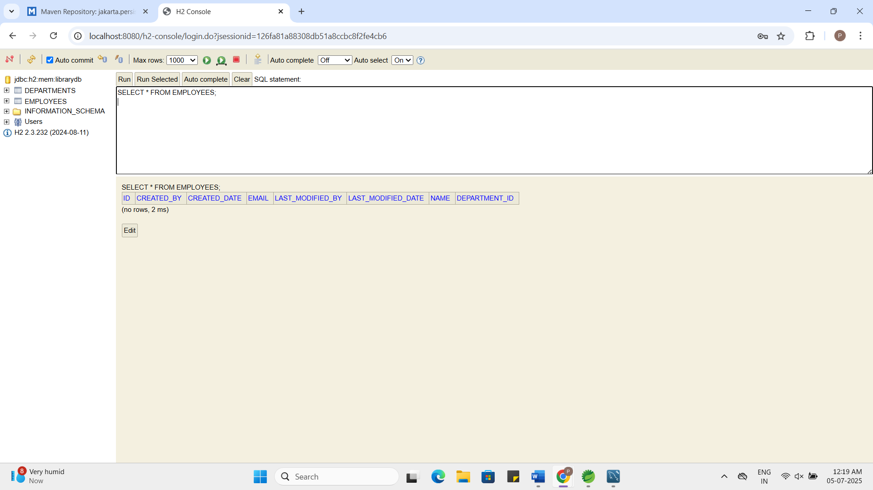

Exercise 8: Employee Management System - Creating Projections
Business Scenario:
Create projections to fetch specific data subsets from the employee and department entities.
Instructions:
- Projections:
  - Define interface-based and class-based projections.
  - Use @Value and constructor expressions to control the fetched data.
EmployeeDTO.java:
package com.employee.dto;

public class EmployeeDTO {
private String name;
private String departmentName;

public EmployeeDTO(String name, String departmentName) {
this.name = name;
this.departmentName = departmentName;
}

public String getName() {
return name;
}

public String getDepartmentName() {
return departmentName;
}
}
EmployeeNameEmail.java:
package com.employee.projection;
public interface EmployeeNameEmail {
String getName();
String getEmail();
}
EmployeeController.java:
package com.employee.controller;
import com.employee.dto.EmployeeDTO;
import com.employee.model.Employee;
import com.employee.projection.EmployeeNameEmail;
import com.employee.repository.EmployeeRepository;
import org.springframework.beans.factory.annotation.Autowired;
import org.springframework.data.domain.*;
import org.springframework.web.bind.annotation.*;
import java.util.List;
@RestController
@RequestMapping("/employees")
public class EmployeeController {
@Autowired
private EmployeeRepository employeeRepository;
@PostMapping
public Employee createEmployee(@RequestBody Employee employee) {
return employeeRepository.save(employee);
}
@GetMapping
public List<Employee> getAllEmployees() {
return employeeRepository.findAll();
}
@GetMapping("/{id}")
public Employee getEmployeeById(@PathVariable Long id) {
return employeeRepository.findById(id).orElse(null);
}
@PutMapping("/{id}")
public Employee updateEmployee(@PathVariable Long id, @RequestBody Employee updated) {
return employeeRepository.findById(id).map(emp -> {
emp.setName(updated.getName());
emp.setEmail(updated.getEmail());
emp.setDepartment(updated.getDepartment());
return employeeRepository.save(emp);
}).orElse(null);
}
@DeleteMapping("/{id}")
public void deleteEmployee(@PathVariable Long id) {
employeeRepository.deleteById(id);
}
@GetMapping("/search/by-name")
public List<Employee> getEmployeesByName(@RequestParam String name) {
return employeeRepository.findByName(name);
}
@GetMapping("/search/by-email-domain")
public List<Employee> getEmployeesByEmailDomain(@RequestParam String domain) {
return employeeRepository.findByEmailDomain(domain);
}
@GetMapping("/search/by-name-keyword")
public List<Employee> getEmployeesByNameKeyword(@RequestParam String keyword) {
return employeeRepository.searchByNameKeyword(keyword);
}

@GetMapping("/search/by-name-prefix")
public List<Employee> getEmployeesByNamePrefix(@RequestParam String prefix) {
return employeeRepository.findByName(prefix);
}
@GetMapping("/search/by-department-id")
public List<Employee> getEmployeesByDepartmentId(@RequestParam Long deptId) {
return employeeRepository.findByDepartmentId(deptId);
}
@GetMapping("/paginated")
public Page<Employee> getPaginatedEmployees(
@RequestParam(defaultValue = "0") int page,
@RequestParam(defaultValue = "5") int size,
@RequestParam(defaultValue = "id") String sortBy,
@RequestParam(defaultValue = "asc") String sortDir) {
Sort sort = sortDir.equalsIgnoreCase("asc")
? Sort.by(sortBy).ascending()
: Sort.by(sortBy).descending();
Pageable pageable = PageRequest.of(page, size, sort);
return employeeRepository.findAll(pageable);
}
@GetMapping("/projections/interface")
public List<EmployeeNameEmail> getEmployeeNameEmail() {
return employeeRepository.findAllNameAndEmail();
}
@GetMapping("/projections/class")
public List<EmployeeDTO> getEmployeeDTOs() {
return employeeRepository.fetchEmployeeWithDepartment();
}

}
EmployeeRepository.java:
package com.employee.repository;
import com.employee.model.Employee;
import org.springframework.data.jpa.repository.JpaRepository;
import org.springframework.data.jpa.repository.Query;
import org.springframework.data.repository.query.Param;
import com.employee.projection.EmployeeNameEmail;
import com.employee.dto.EmployeeDTO;
import java.util.List;
public interface EmployeeRepository extends JpaRepository<Employee, Long> {
List<Employee> findByName(String name);
List<Employee> findByEmailContaining(String keyword);
List<Employee> findByDepartmentName(String departmentName);
@Query("SELECT e FROM Employee e WHERE e.email LIKE %:emailDomain")
List<Employee> findByEmailDomain(@Param("emailDomain") String domain);
@Query(value = "SELECT * FROM employees WHERE name LIKE %:keyword%", nativeQuery = true)
List<Employee> searchByNameKeyword(@Param("keyword") String keyword);
List<Employee> findByDepartmentId(Long departmentId);
@Query("SELECT e FROM Employee e")
List<EmployeeNameEmail> findAllNameAndEmail();
@Query("SELECT new com.employee.dto.EmployeeDTO(e.name, e.department.name) FROM Employee e")
List<EmployeeDTO> fetchEmployeeWithDepartment();
}
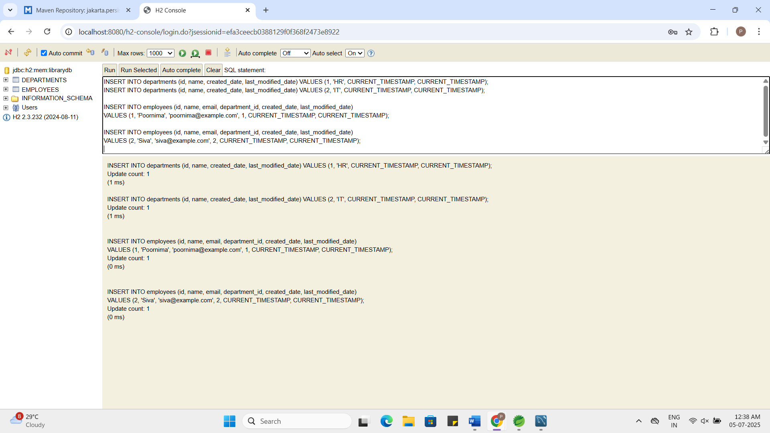

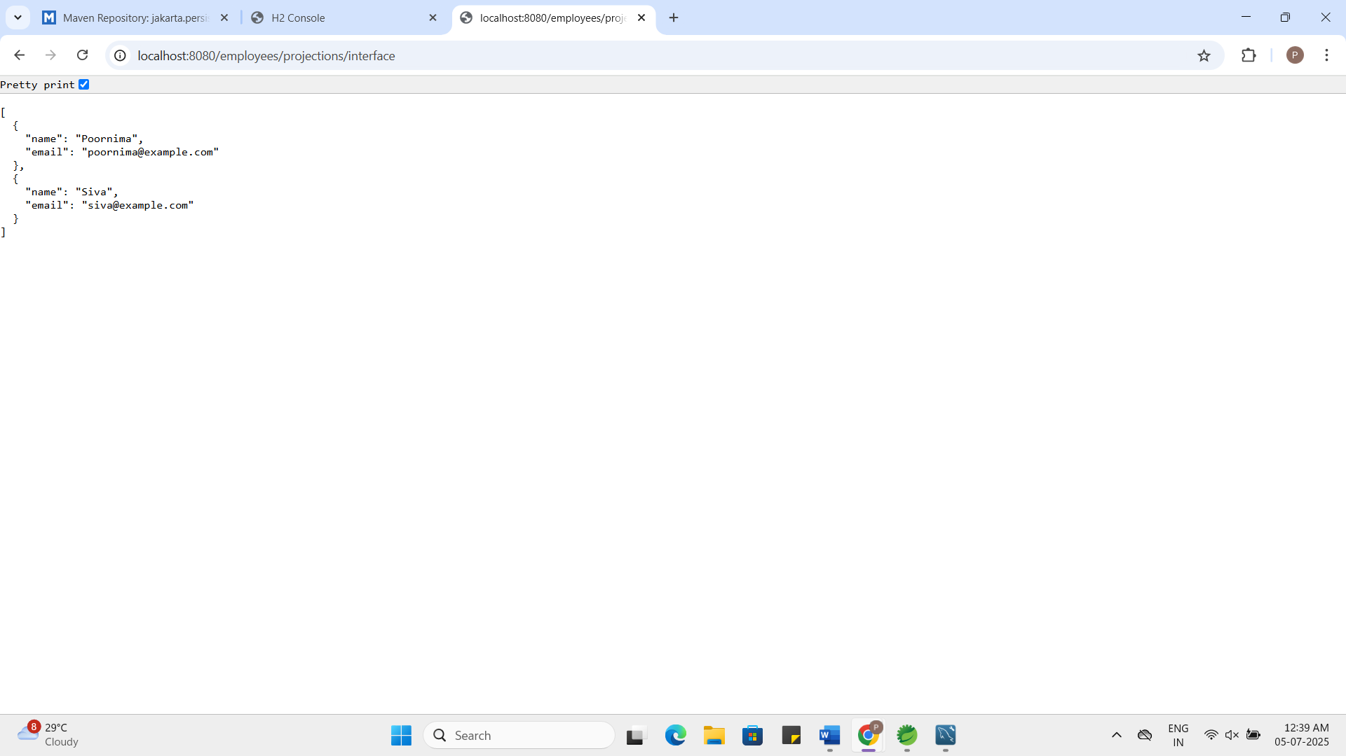

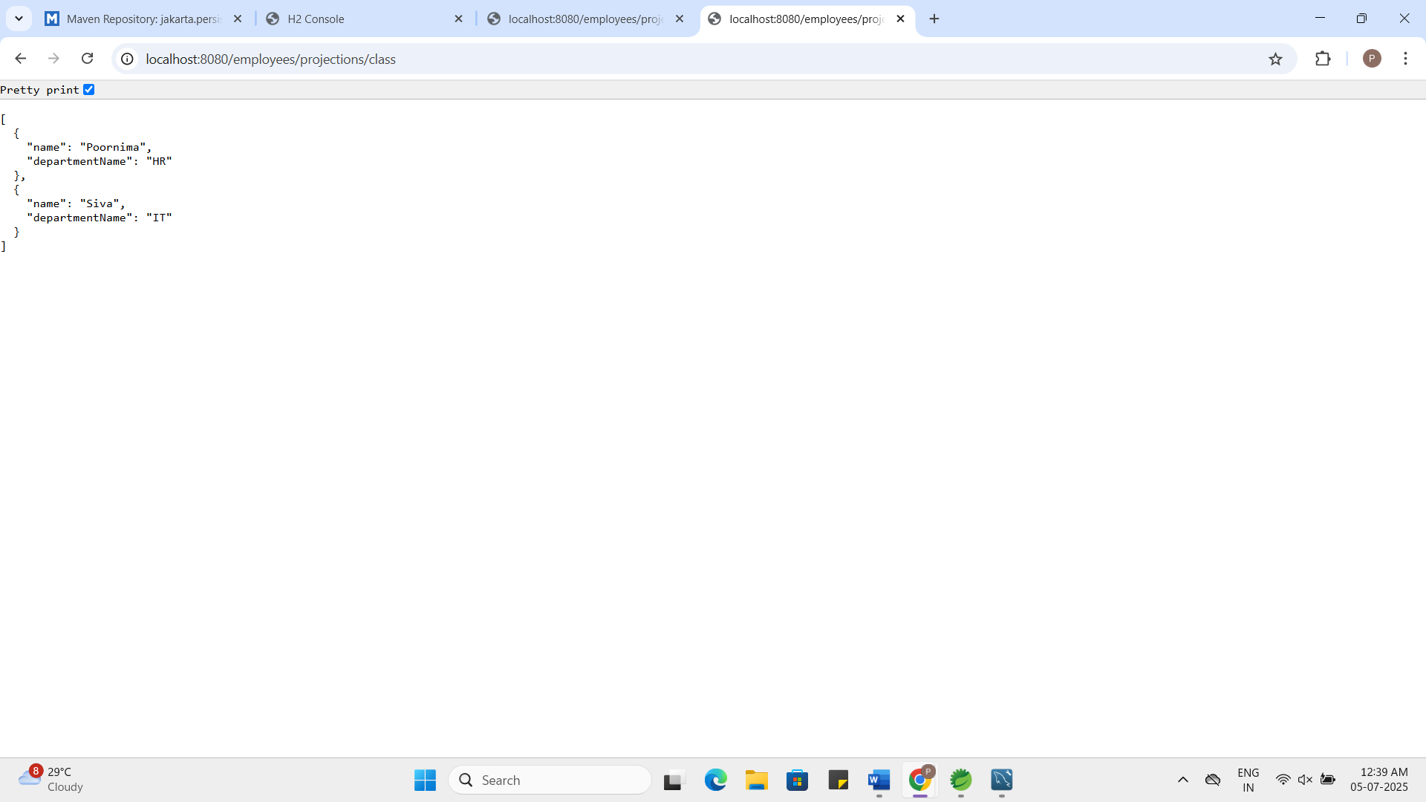

Exercise 9: Employee Management System - Customizing Data Source Configuration
Business Scenario:
Customize your data source configuration and manage multiple data sources.
Instructions:
- Spring Boot Auto-Configuration:
  - Leverage Spring Boot auto-configuration for data sources.
- Externalizing Configuration:
  - Externalize configuration with application.properties.
  - Manage multiple data sources within your application.
PrimaryDataSourceConfig.java:
package com.employee.config;
import javax.sql.DataSource;
import org.springframework.beans.factory.annotation.Qualifier;
import org.springframework.boot.autoconfigure.orm.jpa.JpaProperties;
import org.springframework.boot.orm.jpa.EntityManagerFactoryBuilder;
import org.springframework.boot.jdbc.DataSourceBuilder;
import org.springframework.boot.context.properties.ConfigurationProperties;
import org.springframework.context.annotation.*;
import org.springframework.data.jpa.repository.config.EnableJpaRepositories;
import org.springframework.orm.jpa.*;
import org.springframework.transaction.PlatformTransactionManager;
import org.springframework.transaction.annotation.EnableTransactionManagement;
import jakarta.persistence.EntityManagerFactory;
import java.util.HashMap;

@Configuration
@EnableTransactionManagement
@EnableJpaRepositories(
basePackages = "com.employee.repository", // adjust package
entityManagerFactoryRef = "primaryEntityManagerFactory",
transactionManagerRef = "primaryTransactionManager"
)
public class PrimaryDataSourceConfig {

@Bean(name = "primaryDataSource")
@ConfigurationProperties(prefix = "spring.datasource.primary")
public DataSource primaryDataSource() {
return DataSourceBuilder.create().build();
}

@Bean(name = "primaryEntityManagerFactory")
public LocalContainerEntityManagerFactoryBean primaryEntityManagerFactory(
EntityManagerFactoryBuilder builder,
@Qualifier("primaryDataSource") DataSource dataSource) {

return builder
.dataSource(dataSource)
.packages("com.employee.model")
.persistenceUnit("primary")
.build();
}

@Bean(name = "primaryTransactionManager")
public PlatformTransactionManager primaryTransactionManager(
@Qualifier("primaryEntityManagerFactory") EntityManagerFactory entityManagerFactory) {

return new JpaTransactionManager(entityManagerFactory);
}
}
EmployeeController.java:

package com.employee.controller;
import com.employee.dto.EmployeeDTO;
import com.employee.model.Employee;
import com.employee.projection.EmployeeNameEmail;
import com.employee.repository.EmployeeRepository;
import org.springframework.beans.factory.annotation.Autowired;
import org.springframework.data.domain.*;
import org.springframework.web.bind.annotation.*;
import java.util.List;
@RestController
@RequestMapping("/employees")
public class EmployeeController {
@Autowired
private EmployeeRepository employeeRepository;
@PostMapping
public Employee createEmployee(@RequestBody Employee employee) {
return employeeRepository.save(employee);
}
@GetMapping
public List<Employee> getAllEmployees() {
return employeeRepository.findAll();
}
@GetMapping("/{id}")
public Employee getEmployeeById(@PathVariable Long id) {
return employeeRepository.findById(id).orElse(null);
}
@PutMapping("/{id}")
public Employee updateEmployee(@PathVariable Long id, @RequestBody Employee updated) {
return employeeRepository.findById(id).map(emp -> {
emp.setName(updated.getName());
emp.setEmail(updated.getEmail());
emp.setDepartment(updated.getDepartment());
return employeeRepository.save(emp);
}).orElse(null);
}
@DeleteMapping("/{id}")
public void deleteEmployee(@PathVariable Long id) {
employeeRepository.deleteById(id);
}
@GetMapping("/search/by-name")
public List<Employee> getEmployeesByName(@RequestParam String name) {
return employeeRepository.findByName(name);
}
@GetMapping("/search/by-email-domain")
public List<Employee> getEmployeesByEmailDomain(@RequestParam String domain) {
return employeeRepository.findByEmailDomain(domain);
}
@GetMapping("/search/by-name-keyword")
public List<Employee> getEmployeesByNameKeyword(@RequestParam String keyword) {
return employeeRepository.searchByNameKeyword(keyword);
}
@GetMapping("/search/by-name-prefix")
public List<Employee> getEmployeesByNamePrefix(@RequestParam String prefix) {
return employeeRepository.findByName(prefix);
}
@GetMapping("/search/by-department-id")
public List<Employee> getEmployeesByDepartmentId(@RequestParam Long deptId) {
return employeeRepository.findByDepartmentId(deptId);
}
@GetMapping("/paginated")
public Page<Employee> getPaginatedEmployees(
@RequestParam(defaultValue = "0") int page,
@RequestParam(defaultValue = "5") int size,
@RequestParam(defaultValue = "id") String sortBy,
@RequestParam(defaultValue = "asc") String sortDir) {

Sort sort = sortDir.equalsIgnoreCase("asc")
? Sort.by(sortBy).ascending()
: Sort.by(sortBy).descending();

Pageable pageable = PageRequest.of(page, size, sort);
return employeeRepository.findAll(pageable);
}
@GetMapping("/projections/interface")
public List<EmployeeNameEmail> getEmployeeNameEmail() {
return employeeRepository.findAllNameAndEmail();
}
@GetMapping("/projections/class")
public List<EmployeeDTO> getEmployeeDTOs() {
return employeeRepository.fetchEmployeeWithDepartment();
}

}

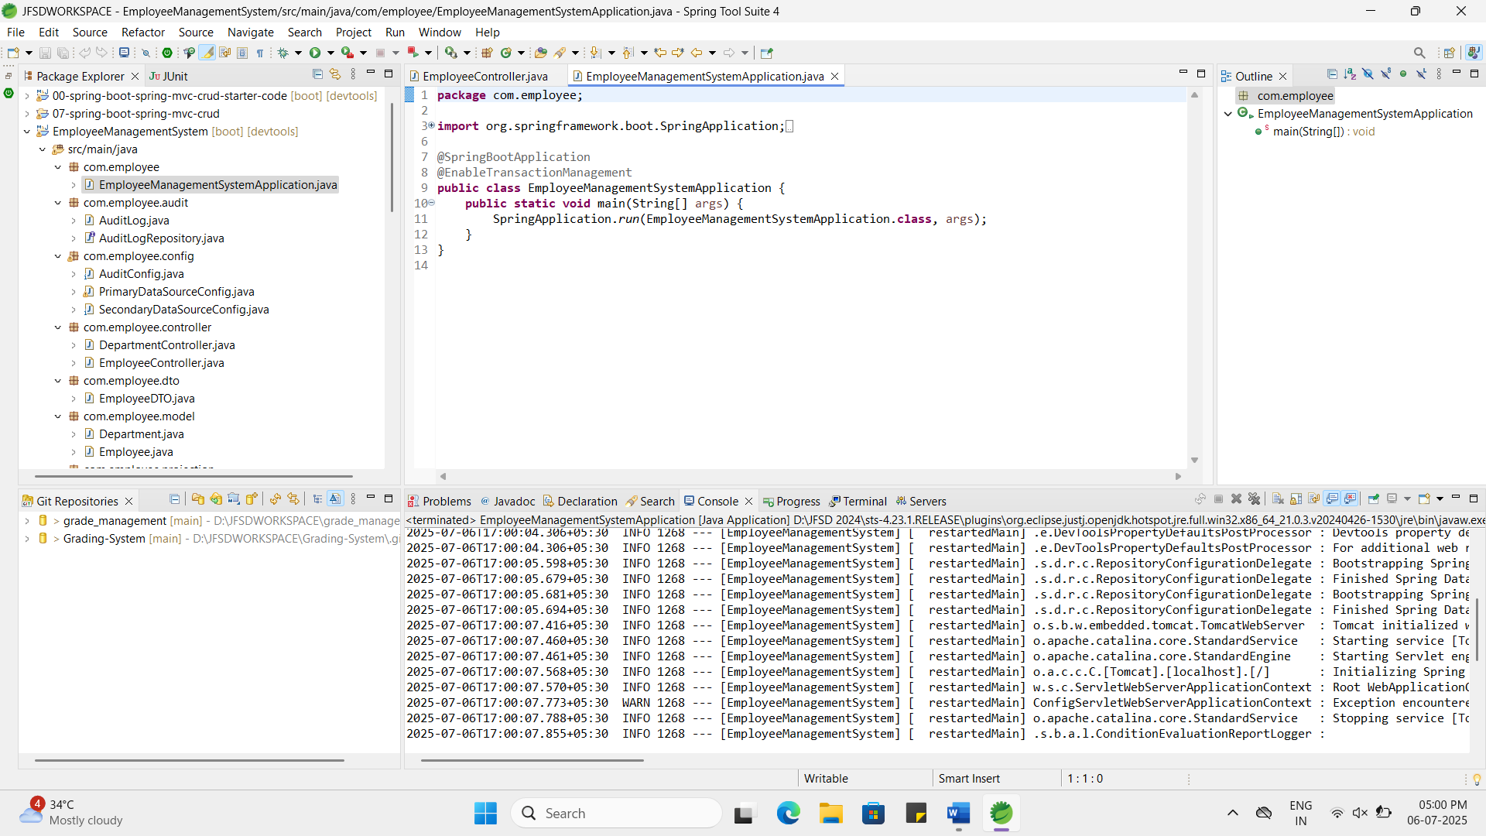
Exercise 10: Employee Management System - Hibernate-Specific Features
Business Scenario:
Leverage Hibernate-specific features to enhance your application's performance and capabilities.
Instructions:
- Hibernate-Specific Annotations:
  - Use Hibernate-specific annotations to customize entity mappings.
- Configuring Hibernate Dialect and Properties:
  - Configure Hibernate dialect and properties for optimal performance.
- Batch Processing:
  - Implement batch processing with Hibernate for bulk operations.
EmployeeService.java:
package com.employee.service;
import com.employee.model.Employee;
import com.employee.repository.EmployeeRepository;
import jakarta.persistence.EntityManager;
import jakarta.persistence.PersistenceContext;
import org.springframework.stereotype.Service;
import org.springframework.transaction.annotation.Transactional;
import java.util.List;
@Service
public class EmployeeService {
private final EmployeeRepository employeeRepository;
@PersistenceContext
private EntityManager entityManager;
public EmployeeService(EmployeeRepository employeeRepository) {
this.employeeRepository = employeeRepository;
}
@Transactional
public void batchInsertEmployees(List<Employee> employees) {
int batchSize = 30;
for (int i = 0; i < employees.size(); i++) {
entityManager.persist(employees.get(i));
if (i % batchSize == 0 && i > 0) {
entityManager.flush();
entityManager.clear();
}
}

entityManager.flush();
entityManager.clear();
}
}

application.proprties:
spring.application.name=EmployeeManagementSystem
# Primary datasource
spring.datasource.url=jdbc:h2:mem:employeesdb
spring.datasource.driver-class-name=org.h2.Driver
spring.datasource.username=root
spring.datasource.password=admin
spring.jpa.show-sql=true
spring.jpa.hibernate.ddl-auto=update
spring.jpa.properties.hibernate.dialect=org.hibernate.dialect.H2Dialect
spring.jpa.properties.hibernate.format_sql=true
# Hibernate performance tuning
spring.jpa.properties.hibernate.jdbc.batch_size=30
spring.jpa.properties.hibernate.order_inserts=true
spring.jpa.properties.hibernate.order_updates=true
spring.jpa.properties.hibernate.generate_statistics=true
